10-Year Preserve Management Plan
2024 Amendment
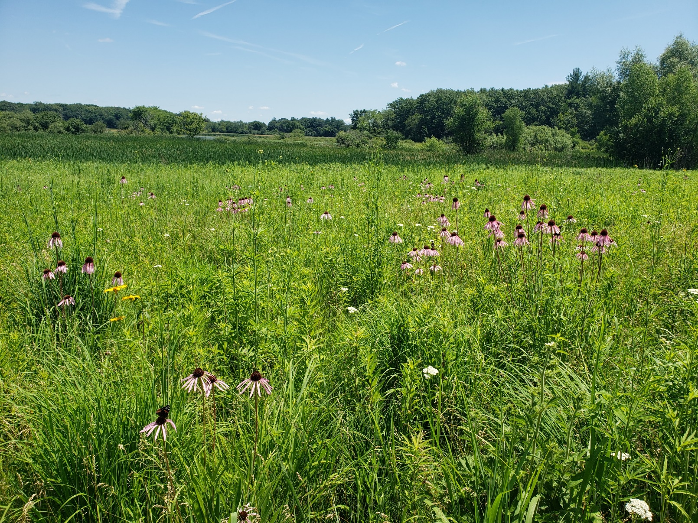
Lake Ripley, Jefferson County, Wisconsin
Sponsored by the Lake Ripley Management District

Board Members:
Jimmy DeGidio
Debbie Kutz
Georgia Gómez-Ibáñez
Doug Maurer
Steve Bieschke
Meg Turville-Heitz – Jefferson County Representative

AMENDMENT 1 - 2024
Preserve Management Plan, Lake Ripley Management District, Jefferson County, Wisconsin

Prepared by Lake Ripley Management District (LRMD) Lake Manager, Lianna Spencer.

Introduction
This is the first amendment to the 10-year Preserve Management Plan, Lake Ripley, Jefferson County, Wisconsin, published on December 14, 2021, by the Lake Ripley Management District. The Wisconsin Department of Natural Resources approved the 10-year Lake Management Plan on December 7, 2021. The Lake Ripley Management District approved the 10-year Lake Management Plan on December 4, 2021.
Since the December 7, 2021, publication of the LRMD’s Preserve Management Plan, the District has identified new issues that could impact the Preserve. Below is Amendment 1.

Upland Prairie Zone 1
Intervention Management Actions:
- Manage reed canary grass through different management actions including but not limited to: removing seed-heads, digging out, burning, mowing, shading out, and herbicide treatments, as the annual budget and volunteer participation allows.
Management Actions:
- Manage undesirable species through different management actions including but not limited to: habitat manipulation, nutrient management, biomanipulation, pesticide application, chemical control, prescribed fire, biological control, and mechanical control, as the annual budget and volunteer participation allows.

Upland Prairie Zone 2
Management Actions:
- Manage undesirable species through different management actions including but not limited to: habitat manipulation, nutrient management, biomanipulation, pesticide application, chemical control, prescribed fire, biological control, and mechanical control, as the annual budget and volunteer participation allows.

Upland Prairie Zone 3
Management Actions:
- Manage undesirable species through different management actions including but not limited to: habitat manipulation, nutrient management, biomanipulation, pesticide application, water level manipulation, chemical control, prescribed fire, biological control, and mechanical control, as the annual budget and volunteer participation allows.

Wetland Zone 1
Management Actions:
- Manage undesirable species through different management actions including but not limited to: habitat manipulation, nutrient management, biomanipulation, pesticide application, water level manipulation, chemical control, prescribed fire, biological control, and mechanical control, as the annual budget and volunteer participation allows.

Wetland Zone 2
Management Goal: As this wet prairie/wetland has been previously restored and maintained over the years, it is important to maintain and improve its function of protecting the inlet creek. Monitor, manage, and develop projects for any new or existing problems that arise.

Intervention Management Actions:
- Develop and implement projects along the inlet stream to help improve water quality in the lake.
- Investigate the practicality of removing the “spoils” along the inlet stream that prevent the stream water from interacting freely with its wetlands, so that nutrients and sediment can settle out.
  - Develop and implement projects that would remove the “spoils” along the inlet stream to allow nutrients and sediment to settle out.
- Explore the feasibility and priority of re-meandering the inlet stream to fully restore the partnership of stream and wetlands, to improve water quality in the lake.
  - Work with landowners adjacent to the inlet stream to develop support and partnership.

Management Actions:
- Manage hybrid cattail and invasive cattail grass through different management actions including but not limited to: habitat manipulation, nutrient management, biomanipulation, pesticide application, water level manipulation, chemical control, prescribed fire, biological control, mechanical control, and water-level control, as the annual budget and volunteer participation allows.
- Develop and implement projects along the inlet stream to help improve water quality in the lake.
- Manage undesirable species (such as, but not limited to Canada thistle and Dame’s rocket) through different management actions including but not limited to: habitat manipulation, nutrient management, biomanipulation, pesticide application, water level manipulation, population monitoring, chemical control, prescribed fire, biological control, and mechanical control, as the annual budget and volunteer participation allows.

Wetland Zone 3
Management Actions:
- Manage undesirable species through different management actions including but not limited to: habitat manipulation, nutrient management, biomanipulation, pesticide application, water level manipulation, chemical control, prescribed fire, biological control, and mechanical control, as the annual budget and volunteer participation allows.

Woodland Zone 1
Management Actions:
- Forestry mowing and/or hand clearing followed by spot-herbiciding of woody species of undesirable species including but not limited to: buckthorn, honeysuckle, gooseberry, and multiflora rose. During the growing season, apply foliar herbicide application to any resprouts of woody species.
- Manage undesirable species through different management actions including but not limited to: habitat manipulation, nutrient management, biomanipulation, pesticide application, chemical control, prescribed fire, biological control, and mechanical control, as the annual budget and volunteer participation allows.

Woodland Zone 2
Management Actions:
- Manage undesirable species through different management actions including but not limited to: habitat manipulation, nutrient management, biomanipulation, pesticide application, water level manipulation, chemical control, prescribed fire, biological control, and mechanical control, as the annual budget and volunteer participation allows.

Woodland Zone 3
Intervention Management Actions:
- Forestry mowing and/or hand clearing followed by spot-herbiciding of woody species of undesirable species including but not limited to: buckthorn, honeysuckle, gooseberry, and multiflora rose. During the growing season, apply foliar herbicide application to any resprouts of woody species.

Management Actions:
- Manage undesirable species through different management actions including but not limited to: habitat manipulation, nutrient management, biomanipulation, pesticide application, water level manipulation, chemical control, prescribed fire, biological control, and mechanical control, as the annual budget and volunteer participation allows.

Appendix D – Town of Oakland Ordinances