Lake Ripley Management Plan
2024 Amendment
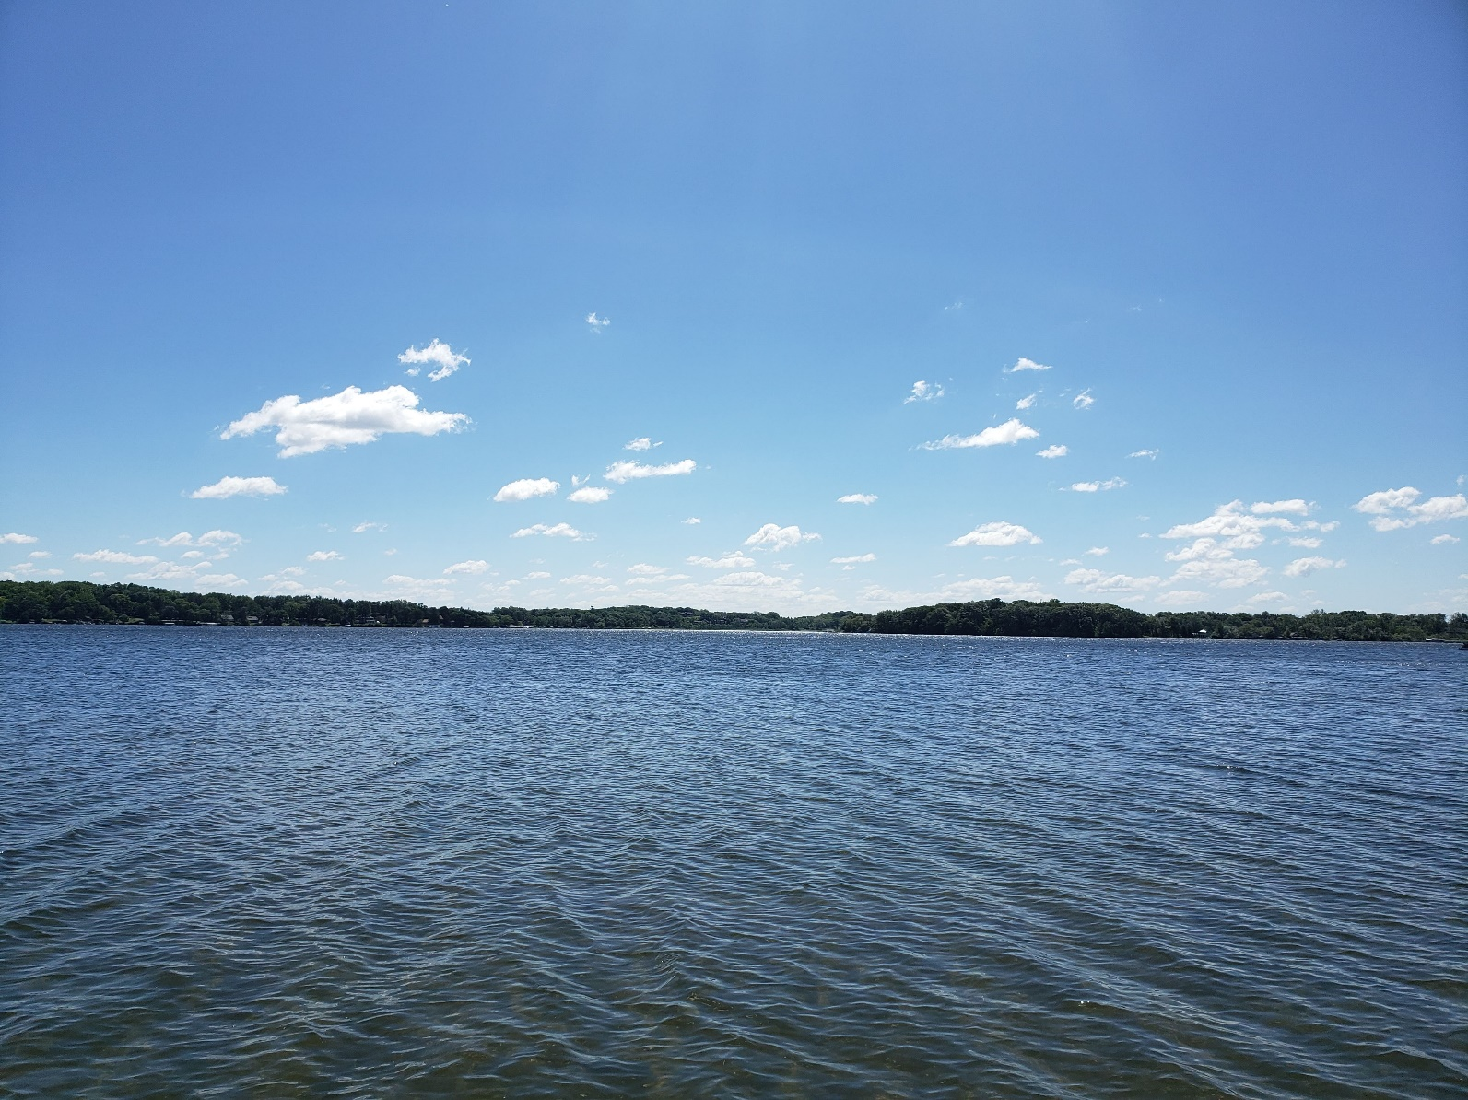
Lake Ripley, Jefferson County, Wisconsin
Sponsored by the Lake Ripley Management District

Board Members:
Jimmy DeGidio
Debbie Kutz
Georgia Gómez-Ibáñez
Doug Maurer
Steve Bieschke
Meg Turville-Heitz – Jefferson County Representative
AMENDMENT 1 - 2024
Lake Management Plan, Lake Ripley, Lake Ripley Management District, Jefferson County, Wisconsin

Prepared by Lake Ripley Management District (LRMD) Lake Manager, Lianna Spencer.

Introduction
This is the first amendment to the 10-year Lake Ripley Lake Management Plan, Lake Ripley, Jefferson County, Wisconsin, published on December 14, 2021, by the Lake Ripley Management District. The Wisconsin Department of Natural Resources approved the 10-year Lake Management Plan on December 7, 2021. The Lake Ripley Management District approved the 10-year Lake Management Plan on December 4, 2021.
Since the December 7, 2021, publication of the LRMD’s Lake Management Plan, the District has identified new issues that could impact Lake Ripley and its watershed. Below is Amendment 1.

CHAPTER 5 - AQUATIC PLANTS

5.5 - Critical Habitat Areas

The District has continued working diligently to protect eight critical habitat or sensitive areas on Lake Ripley. With help from DNR, five of the areas have been designated as ‘Sensitive Areas’ under S. NR 107.05(3)(i)(1), Wisconsin Administrative Code, based on the aquatic vegetation and associated fish and wildlife in these areas and the water quality benefits of these areas of the lake. The other three areas have been designated as ‘Other Critical Habitats’ for their natural or screened shoreline and/or fish and wildlife habitat values. The designation of these eight areas was official in July 2024.
The full Critical Habitat Designation report may be obtained by visiting the DNR website at https://dnr.wisconsin.gov and searching “Critical Habitat Areas”. You may access the report by clicking on the link “Critical Habitat Designation”. The report may be found under “Lake Ripley, Jefferson County – Critical Habitat Designation”.
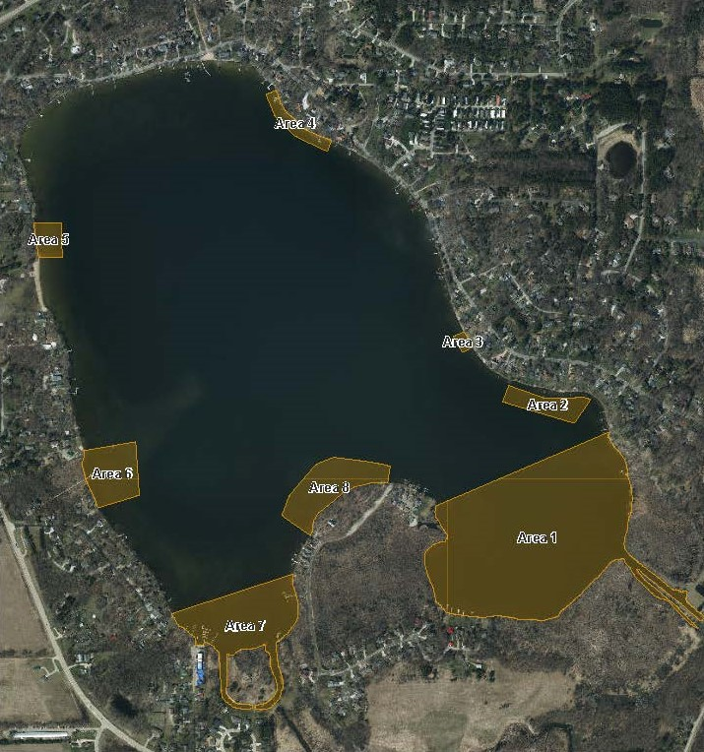

CHAPTER 8 - MANAGEMENT GOALS AND RECOMMENDATIONS

Watershed Goals

Inlet Stream And Wetlands Actions:
- Investigate the practicality of removing the “spoils” along the inlet stream that prevent the stream water from interacting freely with its wetlands, so that nutrients and sediment can settle out.
  - Develop and implement projects that would remove the “spoils” along the inlet stream to allow nutrients and sediment to settle out in the adjacent wetlands.
- Explore the feasibility and priority of re-meandering the inlet stream to fully restore the partnership of stream and wetlands, to improve water quality in the lake.
  - Work with landowners adjacent to the inlet stream to develop support and partnership.
- Develop and implement projects along the inlet stream and tributaries to help improve water quality in the lake.
- Manage the hybrid and invasive cattail in the wetlands. Develop and implement projects to reduce the density of hybrid and invasive cattails. See the 2021-2031 Preserve Management Plan for more information.
- Manage the buckthorn in the wetlands. Develop and implement projects to reduce the density of buckthorn. See the 2021-2031 Preserve Management Plan for more information.

Residential Development Actions:
- Work with the Town of Oakland to create an erosion-control and stormwater management ordinance.
  - Lobby for a county-wide erosion control and stormwater management ordinance.

Water Quality Goals

Water Quality Actions:
- Work with the Town of Oakland on any road, subdivision development or any other type of construction efforts to ensure protection (erosion control practices, etc.) of all waterways and natural resources within the watershed.

Water Quality Sampling Actions:

Continue collecting water quality parameters for the inlet stream to pinpoint any point sources of pollution, and to assess stream and lake health.
  - Collect total suspended solids, total dissolved phosphorus, orthophosphate nitrogen, nitrates, temperature, DO, pH, flow, turbidity, conductivity, and other parameters at four different designated sites along the inlet stream.
- Monitor chloride levels at the deep hole in Lake Ripley during turnover events.
- Collect water quality data from any point within the Lake Ripley watershed, when applicable. Through data analysis and discovery, the District continuously identifies new sites along the inlet stream, within Lake Ripley, or along the outlet creek, that we believe would help us close knowledge/data gaps.

Habitat Goals

Fish Management Actions:

- Continue monitoring for and tracking the status of the lake chubsucker (Erimyzon sucetta), the pugnose shiner (Notropis anogenus), the least darter (Etheostoma microperca), and the banded killifish (Fundulus diaphanous). Rediscovery of these species could be an early indicator of water quality improvements or successful habitat recovery.
  - Due to the low probability of natural recruitment, investigate the merit and feasibility of reintroducing native non-game fish species using approved conservation aquaculture methods.
  - Design a project that reintroduces native non-game fish species using approved conservation aquaculture methods.
  - Implement a project that reintroduces native non-game fish species using approved conservation aquaculture methods.
- Enhance or restore aquatic ecosystems within the lake to support the fishery.

Appendix C - Town of Oakland Ordinances
Town of Oakland Ordinances