Instructions for Ordering Plants for the Native Plant Sale
You can find the plant order form on our website or get it emailed to you. It has seven columns that show you the names of plants (columns A & B) and some of the costs associated with purchasing either a full or partial tray (columns C, D, E, F, & G).
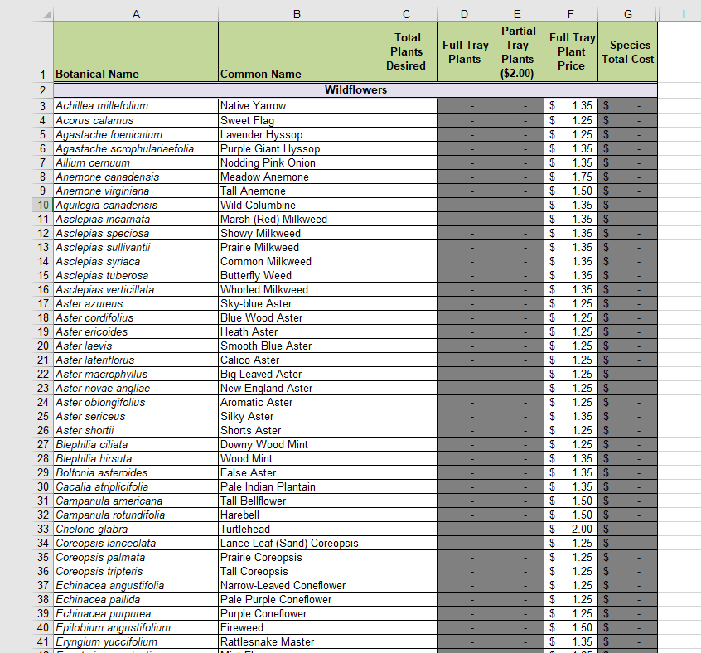

To enter your order information on the spreadsheet: Find the row with your desired plant on the left-hand side of the spreadsheet, and in the “Total Plants Desired” column (marked with a red rectangle in the picture above) for that row, enter the number of individual plants you would like. All plants must be ordered in multiples of 4. If you enter 6 into the spreadsheet, it will automatically correct it to 8. Remember, anything less than 32 plants of one species is a partial tray. Do NOT enter anything in the gray boxes on the spreadsheet.
All of the plant pots are 2.5” x 2.5” by 3.5”.
ONE FULL TRAY OF PLANTS: one full tray of plants consists of 32 individual plants of one specific species. If you want/need 32 individual plants of one specific species – this is the cheaper way to go!
PARTIAL TRAYS: For partial trays of plants, you must order the individual plants in multiples of four (4, 8, 12, 16, etc.). All plants in a partial tray are $2.50/plant. REMEMBER: they are not the “Full Tray Plant Price” cost, as that price only applies to a full tray which is 32 total plants of that one species.
You can either enter the information on the spreadsheet and let the spreadsheet calculate your costs for you, or you can do it by hand. For example: if you want to order 12 nodding pink onions and 4 marsh milkweed, you can put it into the TOTAL PLANTS DESIRED column of the spreadsheet and it will autogenerate the dollar totals for you. If you’d rather do it by hand, simply take the number of plants you want to purchase of that species, and multiply it by $2.50 for the total cost for that species.
This column will autogenerate for you when you enter the number of plants you want
Where you enter the amount of plants you want of that species

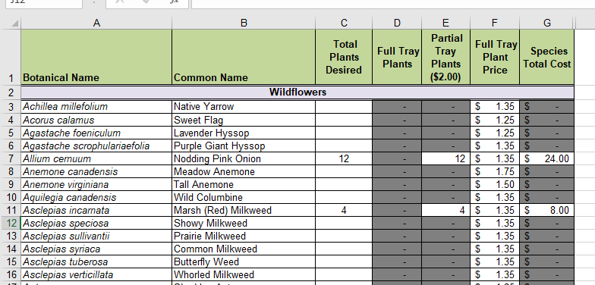
The delivery date for the plants will be sometime in May. You will receive an email or a phone call letting you know the date of pick-up. We will call you that day once we have your plants sorted for you to come and pick them up.

A check or cash is due with your order. You can either drop off cash at the District office or drop off/mail a check made out to the Lake Ripley Management District.

For any other questions or concerns, please contact the Lake Manager for the Lake Ripley Management District by either phone or email.
Email: Lake.manager@tn.oakland.jefferson.wi.gov Phone: 608-423-4537
Address: N4450 County Road A, Cambridge, WI, 53523
Native Plant Sale: Tips for Best Results

Tips for Choosing Plants Appropriate for Your Yard:
Different plants grow best under certain conditions specific to their species. For best results, pay close attention to the requirements listed for each species for:
- Amount of direct sunshine on your site (8 hours is considered “full sun”)
- Soil type and moisture, ranging from “dry” (usually correlated with “sandy” soil), “medium” or “mesic” (usually loamy soil), and “wet” (as in a wetland, a raingarden, but sometimes indicates a clay soil)

Choose only plants that will thrive in your own yard’s sunshine and soil conditions!

Continuous Bloom
Each species has its own bloom period. Most fall into one of three periods: late spring/early summer, midsummer, and late-summer/fall. The Agrecol website lists the bloom period for each species. By choosing plants from each of these bloom periods, you can achieve continuous bloom in your garden. You will enjoy the beauty, and the pollinators will appreciate the reliable nectar source.

Height
For most yards, you will want to avoid plants taller than 4 feet. That information is also shown for each species on the website.

Beyond these considerations, choose for what you find beautiful! There are many shapes and colors to choose from. Try to include flowers of different shapes, especially if you are limiting your range of colors!

How Many Plants Should I Get for My Yard?
Measure your planting site. Plan on planting one plant per square foot. (A 20-foot X 20-foot space will need about 400 plants, etc.)

How Many of Each Species Should I Get?
A “natural” and pleasing appearance is achieved by planting in clumps of uneven numbers (3, 5, 7, 9, etc.). Agrecol requires ordering in multiples of 4. By ordering 8 of each species, for example, you can plant in clumps of 3 and 5 (or 16 and plant in clumps of 7 and 9, etc.). Plants like growing in same-species clumps. It’s how nature arranges things. Pollinators appreciate same-species clumps too – it’s less travel time for them!

Tips for Planting a Large Site (40-feet X 40-feet or larger)
This tip will help you create a scheme that scatters the different bloom times evenly around your site. Choose a color-code for early summer, midsummer, and late summer/fall, and mark the top tips of your plant labels with those colors (choose contrasting colors, for clarity).

Plant your early-bloomers first, setting them out, spaced evenly, across your site, and plant. Next plant the midsummer bloomers, also spaced nicely around your site. Now plant your late summer/fall bloomers.

Caring for Your Plants After Pick-Up and Before Planting
Put in a reliably shady place OUTDOORS and water daily.

Planting and Caring for Your Plants During Their First Summer
- If possible, plant on a cloudy day (less stress for your plants) and water deeply.
- Water once a week deeply (unless you get one inch of rain).
- Mulch will help keep moisture in soil and suppress weeds.
- DO NOT ADD FERTILIZER. Native plants do not like that!
- If fall is dry, water right up to when everything freezes.

Fall Clean-Up and Winter
- Many gardeners cut all flower stalks off close to the ground to “tidy up” in the fall…BUT:
  - Many native flower-heads and grass and sedge seeds are decorative and beautiful all winter long, and
  - They also provide winter food for our winter birds
- If tidiness wins, please cut stalks 1 foot above the ground, because in that lower 12 inches of stalk is where pollinators over-winter as eggs, larvae, or adults. You don’t want your tidying efforts to throw away next year’s pollinators!

