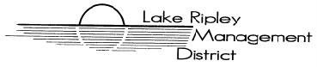
Lake Ripley Management District
Human Resources Committee
Committee Meeting
July 9th, 2021, 7:30AM
Nora’s Two Restaurant
1843 US-12
Deerfield, Wisconsin, 53531
Agenda

- Call to Order and Roll Call

- Public Comment

- Approve Minutes from October 5th, 2020, meeting

- New Business

- Lake Manager evaluation process discussion and possible action

- Old Business

Adjournment

Note: Public Comment will be taken at discretion of District Chair

Original posted at Hering’s Lake Ripley Inn, Lake Ripley Café, Oakland Town Hall on July 2, 2021. Posted to the Lake Ripley Management District website (www.lakeripley.org).

