2022 Boat Census Survey

Introduction
The Lake Ripley Management District completed the annual boat census survey on Lake Ripley on Thursday, July 29th, 2022. It took one hour and 30 minutes to complete the entire loop, starting at 8:55 a.m. and finishing at 10:25 a.m. The survey was conducted Chairman Jimmy DeGidio’s, pontoon boat by Jimmy DeGidio and the Lake Manager, Lianna Spencer. Gary Zibell, from Cambridge TV videotaped the entire shoreline.
As part of the Lake Ripley Management District’s ongoing carrying capacity study, the District conducts a boat census survey every year to document the number of vessels moored on Lake Ripley. By completing this survey, we are able to document the population of local boats of the lake as well as the changes happening in our littoral and riparian buffer zones each year. We count all boats, motorized and nonmotorized, as well as swim mats, boat lifts and piers.

Methods
The crew completed the loop traveling counterclockwise fairly close to the shoreline on Lake Ripley. The pontoon was traveling slow enough to not create any wake the entire time; this gave the crew the ability to accurately count all vessels, swim mats, lifts and piers. The weather was sunny with few clouds, and the temperature was 87°F. The survey was video recorded so that it can be watched later, if needed.

Results
This year, the crew counted 182 piers, 242 boats lifts (not including the marina), 200 pontoon boats, 117 speed boats, 25 fishing boats, 49 jet skis, 184 kayaks/paddleboards, 20 canoes/nonmotor, 15 paddleboats, 7 sailboats, and 26 swim mats. Boat lifts were not counted during the 2019 survey, so we were unable to compare the results for that category.
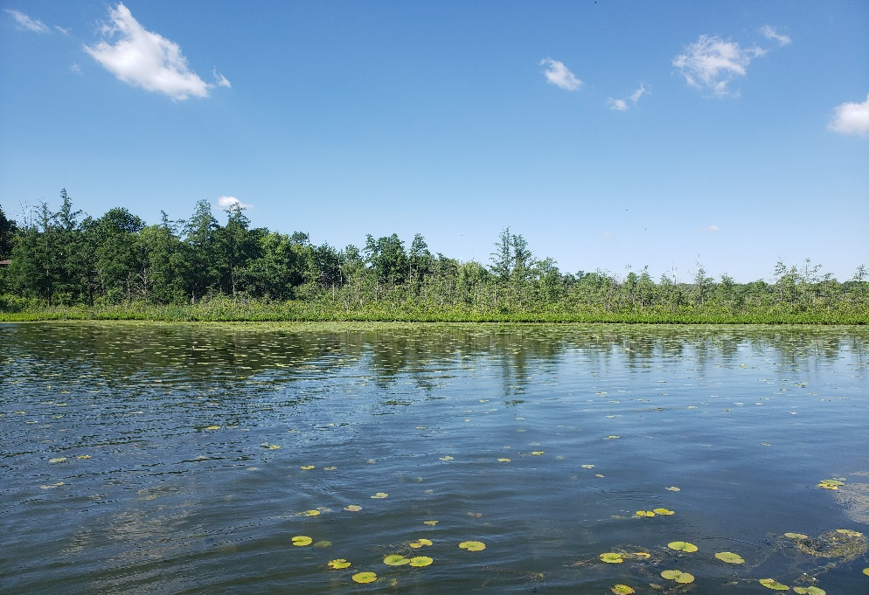
Since 2021, there has been one additional pier installed in Lake Ripley. Since 2021, there has also been an increase in both motorboats and non-motorboats including an additional 8 fishing boats, 28 kayaks/paddleboards, and 2 swim mats/rafts to the lake this season. There were four categories that saw a decrease in numbers since 2021. Speedboats have decreased by 3, jet skis have decreased by one, sailboats have decreased by 4, and pontoon boats have decreased by 5. The number of paddleboats did not change. In total there were 617 vessels recorded on the lake, which is four more vessels than the 2021 boat census survey. Swim rafts/mats were not included in the referenced number as they are not vessels.
Figure 1: Photo of the conditions from that day.

Discussion
We saw another big increase in kayaks and paddleboards this year. During the 2020 survey the number of kayaks/paddleboards increased by 28, and during the 2022 survey this number grew an additional 28, making the total number of kayaks/paddleboards on the lake 184.
Over the last two years, it seems as if there is a trend forming that suggests that over time there may be fewer motorized vessels and more non-motorized vessels. Although the total number of vessels on the lake increased by four, that number is representative of the increase in kayaks/paddleboards.

