Stormwater Runoff Program

What is the Stormwater Runoff Program?
The District is implementing a new program to improve water quality in the lake by improving the absorption of run-off in the stormwater ditches constructed during the rebuilding of Ripley Road.
These ditches were designed to intercept, hold, transport, and absorb runoff water. Their size was determined by engineering studies done especially for Ripley Road, for heavy rainfall events. Thus, it is very important to not alter their size or shape!
But the functioning of these ditches can be improved by planting appropriate native plants in them. Neither turf grass nor ordinary, cultivated flowers can improve the stormwater function of ditches. Native plants all have deep fibrous roots that can withstand the unusual conditions of ditches, with their alternating dry/deep water. The appropriate selection of native flowering plants, grasses, and sedges can and will reduce erosion, and trap pollutants and sediments that would otherwise eventually reach the lake.
We are implementing a modified cost-share program to provide assistance to owners whose frontage has been changed by these ditches on Ripley Road. Because the ditches are in the Town right-of-way, this agreement would not include an easement, but rather an agreement to care for the planting. We’re calling it “The Ditch

What we are we looking for?
A stormwater ditch is an open, manmade waterway that drains stormwater runoff. Ditches are designed to intercept, hold, transport, and absorb runoff water. They are important in preventing flooding along Ripley Road.
We are looking to collaborate with property owners along Ripley Road to plant appropriate native plants in their ditches along their frontage. We see an opportunity to demonstrate that this will be an important contribution to our water quality in the lake.
Types of Ditch Plantings

- Native Vegetated Mats (NVM)
Native vegetated mats consist of a coir reinforcing mat, soilless growing medium and native vegetation. The mats are easy to install with minimal site preparation, quick to grow and require minimal weeding and maintenance. These mats are perfect for rain gardens, shorelines, and stormwater ditches where slopes make planting individual plants more difficult.
Native vegetated mats cost $40/square yard. If your ditch is smaller in size, this might be the best option for you! The mats are up to 250lb; delivery through Agrecol is available if necessary. There are two different harvest times for the NVMs. The first harvest is in mid-July, and the second harvest is in mid-October; this gives you the option of planting in the summer or the fall.

Site Preparation and Planting
Eliminate all existing unwanted vegetation by using an aquatic-safe herbicide, through repeated weeding, or with smothering techniques. Loosen the soil to allow rapid deep root development of natives. Amend soil with clean compost or other media and mix into surface to decrease transitional rooting time into existing soil. Smooth the soil surface to prevent root pruning from air gaps.

Maintenance
Watering
Water the plants heavily at the time of planting. Plants will need to be watered daily for 2-3 weeks, and then twice per week until the roots are established (approximately 6-8 weeks or at the end of the first growing season). A half-inch of rainfall can replace one watering session. The plants will need to be watered regularly during the first years’ growing season.
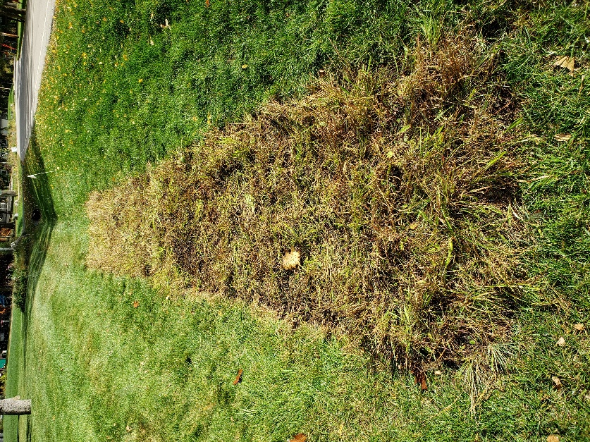

Weeding
After you have planted the mat, there will be little weeding needed at the onset. After the first year, the site will need to be weeded at least once a season. Once the plants have grown and filled in, much less maintenance will be required.

- Plant Plugs
Planting native plant plugs at one plant per square foot (at $2/plant or less through the District’s native plant sale!) is the most cost-effective, but it does require more maintenance, including the installation of an erosion control blanket, and weeding. The erosion control blanket should be 100% coconut fiber or net-free excelsior material.

Site Preparation and Planting
Prior to planting, this site will need to be sprayed with an aquatic approved herbicide a few weeks before planting. There is no need to clean up the dead grass, as the new plants will be planted within the dead turf grass to prevent erosion until the plants have grown and spread. Install a 100% coconut fiber or net-free excelsior erosion control blanket before planting any native plants at the site. This will provide protection to both the soil and the plants if a heavy rainfall event would occur as they are establishing themselves. The plants should be planted 1 plant per square foot.

Maintenance
Watering
Water the plants heavily at the time of planting. Plants will need to be watered daily for 2-3 weeks, and then twice per week until the roots are established (approximately 6-8 weeks or at the end of the first growing season). A half-inch of rainfall can replace one watering session. The plants will need to be watered regularly during the first years’ growing season.
Weeding
After you have planted your natives, the ditch will need to be weeded approximately every week. After the first two years, the ditch should only need to be weeded once or twice a year.

General Maintenance
Keep an eye out for any areas that appear to be eroding. These areas can be planted denser with plants or, if needed, stones places over geotextile fabric can be utilized to prevent erosion. Mulching is not suggested since mulch can get washed away and clog pipes downstream.
Thank you for your interest in partnering with the Lake Ripley Management District in a project that will protect and improve the water quality of Lake Ripley. We support projects that benefit the lake as a whole, such as helping infiltrate stormwater run-off before it reaches the lake!
Things to consider when designing your ditch:
- Are there utilities to avoid when planting? (Plant plugs are only 3” deep)
- When was the last time the ditch was dug out for utility work? Will that be happening soon?
- Does the location have mostly sun or shade? (This will affect appropriate plant choices.)
- What size area do you want to plant and maintain? How far above the top of the ditch would you like to create a buffer? At a minimum, the buffer should extend to the top of the ditch.
- Plants need to be below a certain height (roughly 2-3’) to allow cars in the driveway to see traffic when backing out
- Is there sitting water during the spring and summer? (This will affect appropriate plant choices.)
- Is there a lot of stormwater flowing through the ditch? What is the volume and speed? Are there currently erosion problems? Is there anything blocking the flow of water?
- Is there a lot of road salt in the winter?
- Are you able to provide bi-weekly maintenance, especially in the first two years?

Possible Costs
- Native plants and/or native vegetated mat
  - Native vegetated mat: $220/roll
    - The rolled out NVM will measure: 40” x 11’
  - Native plants are $2.00/plant – take advantage of the District’s annual plant sale!
- Landscaper to install plants if desired
- Erosion control blanket (plugs only)
- Weeding labor
- Watering costs
- Aquatic herbicide and application costs (labor)
- Herbicide/other eradication tool for existing turf or non-desirables
- Site preparation for NVM

What if I want to convert my ditch by myself?
To all those ‘do-it-yourselfers’, we can still offer advice to anyone interested. We can offer a complete planting plan, or a list of appropriate plants for your specific site! Our native plant sale each spring is a convenient and economical way of getting verified native plants (about $2/plant, sometimes less!)
As always, our primary concern is for the lake. Just as shoreline cost-shares have helped maintain water quality, we know ditch cost-shares along Ripley Road will help us achieve our goals for water quality in Lake Ripley.
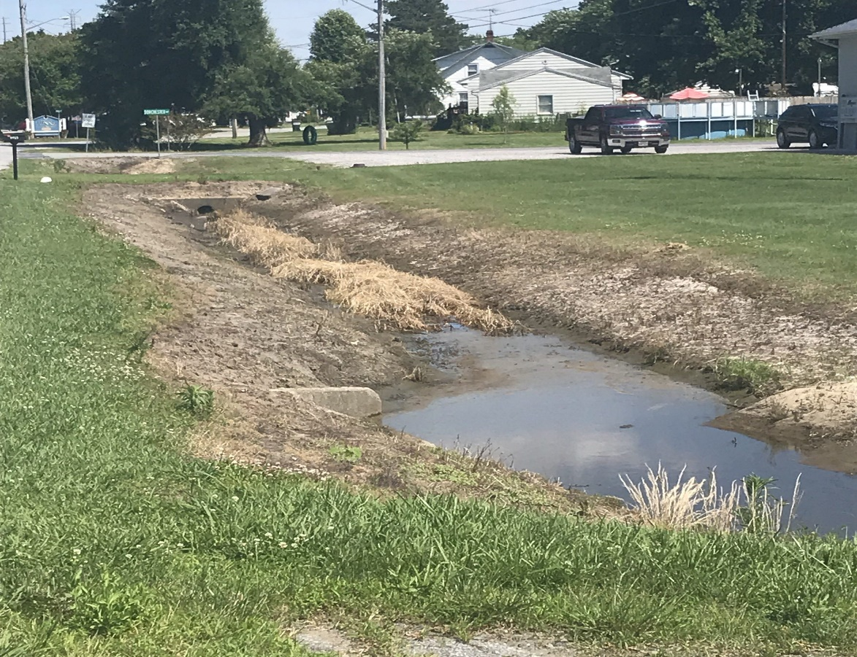
Let’s go from this…

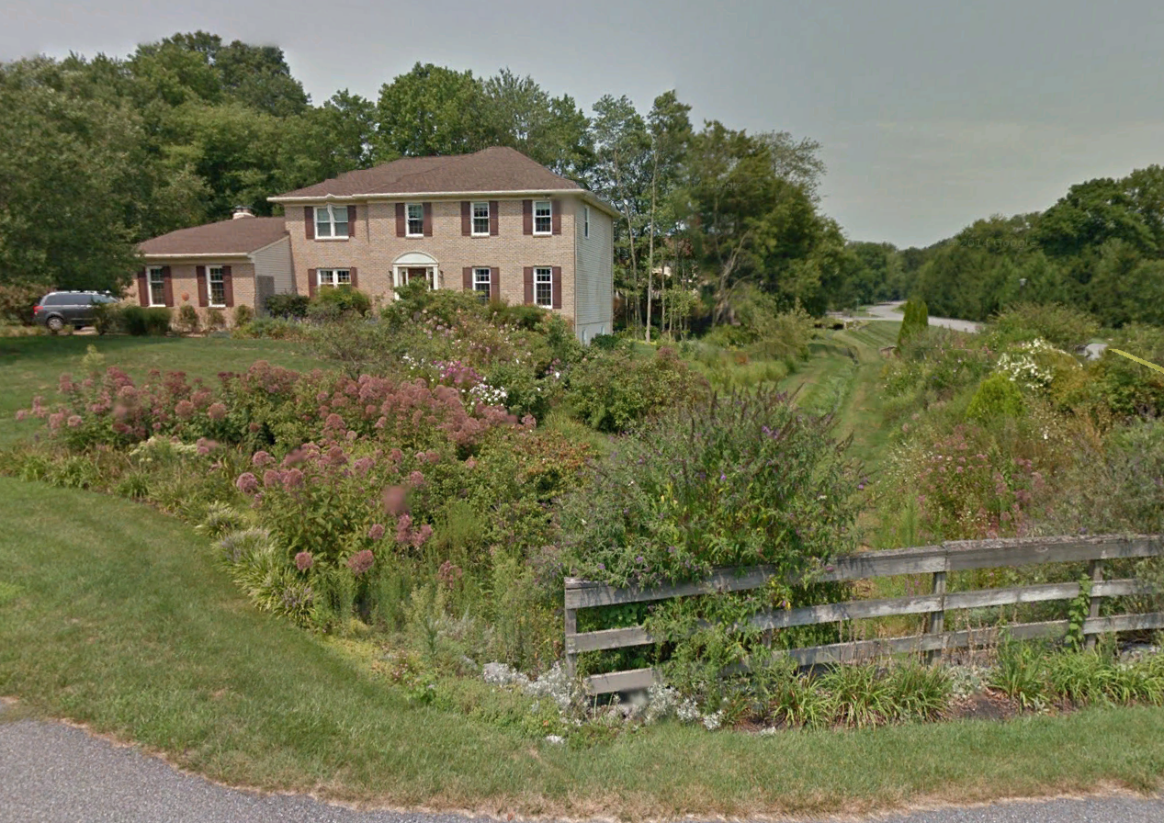
To this!

