Meander Survey of Lake Ripley
Report written by: Lianna Spencer
Summary
Historically, Lake Ripley has had a diverse and abundant native plant population. During the 1970’s two invasive plants, Eurasian watermilfoil and curly-leaf pondweed, entered the lake threatening to cause challenges. Monitoring for invasive species is important; the longer an invasive species presence isn’t known about, the longer it has to create problems within the lake. Educational programs have since been designed to educate lake users about the dangers of aquatic invasive species, and the importance of thoroughly cleaning your vessel after visiting any lake. There have been no new aquatic invasive plant species found in Lake Ripley since 1976.

Introduction
Lake Ripley has been monitoring and controlling Eurasian watermilfoil and curly-leaf pondweed since 1976. Throughout the process of updating our 10-year Lake Management Plan, the District performed multiple plant surveys to determine the most current composition of plants within the lake. A full point-intercept survey was completed to provide the most current plant data, including composition and distribution. Later in the summer a meander-survey was completed around known public access locations, to look for any new invasives in the lake. The meander-survey was recommended by the WDNR; most new invasives species are initially found at public access locations, such as a public boat launch.

Methods
On August 3, 2021, starting at 12:00pm, a meander survey was completed on Lake Ripley by District staff. This survey focused on the presence or absence of any new invasive species, specifically starry stonewort, around known public access locations. During this survey, the two known public access locations were surveyed using a meandering sampling method. The two known access locations are boat launches; there is one public boat launch on the south end of the lake, and a private boat launch on the south-west side of the lake.
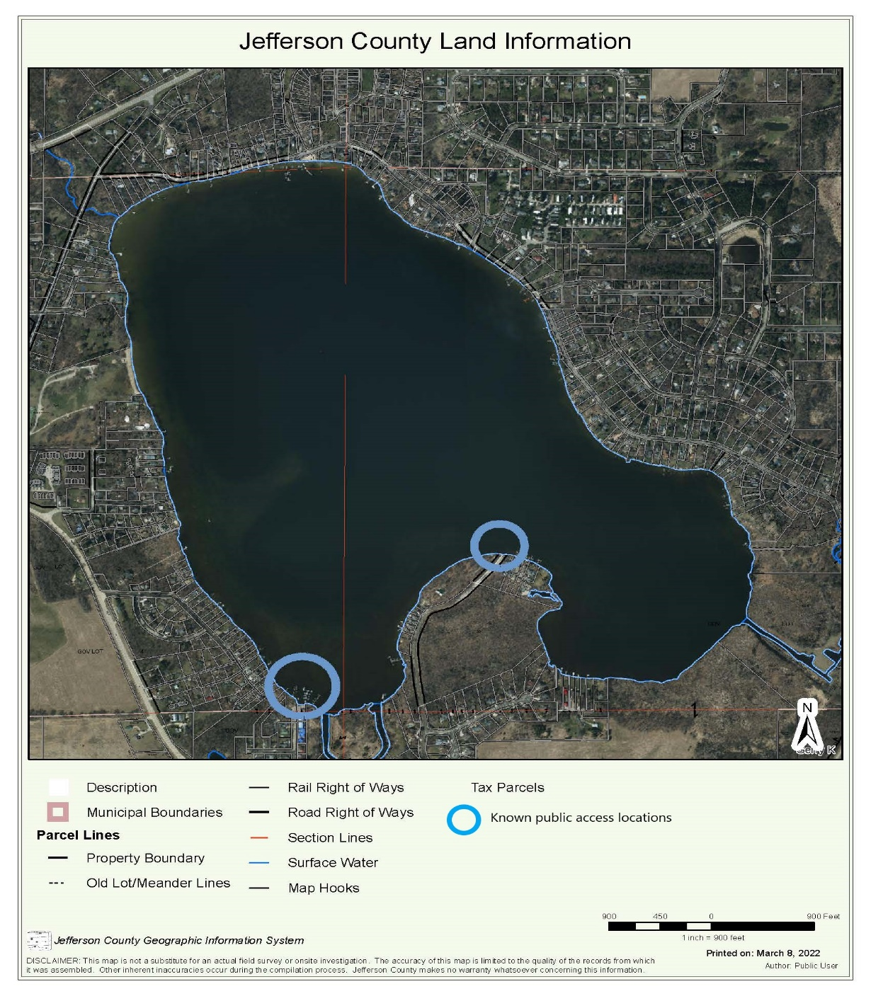
Figure 1: Known public access locations.
The crew completed multiple meanders around each public access location looking for anything out of the ordinary. On multiple occasions, the boat was stopped to drop a rake and check the composition of the plants. The rake was used a rough total of 40 times.

Results
Overall, five plants species were documented during the survey. Water celery (Vallisneria americana), coontail (Ceratophyllum demersum), Sago pondweed (Stuckenia pectinata), chara (Chara sp.), and Eurasian watermilfoil (Myriophyllum spicatum) were all found at both known access locations. There was no evidence of any new invasive species, specifically starry stonewort. No curly-leaf pondweed was observed during this survey.

Discussion
Overall, five different plant species were observed during the meandering survey. No new invasive species were found.
Public access locations, such as boat launches, are hotspots for aquatic invasive species to become established. If a vessel was not properly cleaned off before travelling to a different lake, the invasive species attached to the vessel or in the ballast water could potentially be released into the next lake during unloading. Don’t forget – “Inspect, Remove, Drain!”.

