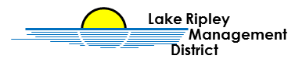
Lake Ripley Management District
Land Acquisition Committee
Committee Meeting
December 28th, 2021 at 10:45am
Oakland Town Hall
N4450 County Road A, Cambridge, WI, 53523
Agenda

- Call to Order and Roll Call

- Public Comment

- Approve Minutes of October 12th, 2021

- New Business

- Discussion with Badger Bank at location (102 W Main St, Cambridge) on possible loan at 11:00am
- Discussion with Hometown Bank at location (221 W Main St, Cambridge) on possible loan at 11:30am

- Old Business

Adjournment

Note: Public Comment will be taken at discretion of District Chair

Original posted at Hering’s Lake Ripley Inn, Lake Ripley Café, Oakland Town Hall on December 23rd, 2021. Posted to www.lakeripley.org on December 23rd, 2021.

