Lake Ripley Watershed Preliminary Design Report
October 21st, 2021
Team 7: Faith Gillen, Will Mockert, Luke Senta, Caroline Skotarzak

Prepared For
Beaver Professional Services
324 Wendt Commons
215 N. Randall Avenue
Madison WI 53715

October 21, 2021
To: Ms. Lianna Spencer
N4450 County Road A
Cambridge, WI 53523

RE: Preliminary Design Report - Engineering Services for Watershed Improvement

Dear Ms. Lianna Spencer,

Attached you will find the preliminary design report of the Engineering Services for Watershed Improvement for the Lake Ripley Management District (LRMD). We at Beaver Professional Services (BPS) have valued the opportunity to work with the LRMD throughout this project and look forward to continuing our services for the design of the watershed improvement and beyond.

BPS has developed the alternative solutions that can be found in this report in order to align the designs with the scope of work that was outlined in the proposal along with the key focuses that were highlighted on the two site visits that our team made. This report considers three alternative solutions in order to redirect the stream inlet to Lake Ripley, with a recommendation of the most suitable.

Each solution is outlined in terms of scope, cost, impact to the surrounding environment, and feasibility so that a fully educated decision can be made. The components of each solution have been analyzed in civil, environmental, geotechnical, hydrological, and survey engineering areas in order to provide solutions that have been inspected from multiple angles to provide a well-rounded product. A decision matrix and a cost analysis are included within this report. Such factors were used to craft our recommendation, please feel free to reference them when making your final determination as well.

The whole team here at Beaver Professional Services would like to reiterate our pleasure and enthusiasm to be able to work alongside the LRMD in order to reroute the inlet stream and improve the water quality in Lake Ripley. We have considered all angles of the project and are excited to work further to implement a detailed design plan for any of the solutions within this report to make a difference in the Lake Ripley community. If there are any questions or comments that you would like to discuss further, please feel free to contact me at any time.

Thank you for your time and consideration,

Caroline R. Skotarzak
Project Manager
Beaver Professional Services

DISCLAIMER: Student Project Documents
The concepts, drawings and written materials provided here were prepared by students in the Department of Civil & Environmental Engineering at the University of Wisconsin-Madison as an activity in the course Civ Engr 578 – Senior Capstone Design/GLE 479 – Geological Engineering Design. These do not represent the work products of licensed Professional Engineers. These are not for construction purposes.

1.0 Executive Summary

1.1 Project Description
Lake Ripley, located in Cambridge, WI, has suffered from poor water quality despite improvement efforts made by the Lake Ripley Management District (LRMD) since 1990. Phosphorus, nitrogen, and suspended solids from agricultural and residential runoff are of particular concern to LRMD currently. See Appendix 1 for reference of historic phosphorus levels in the stream – almost always above the quality standard as set by the DNR. Beaver Professional Services (BPS) is providing engineering design services to improve the Lake Ripley Watershed’s surface water quality through three proposed alternative designs. Each design has a similar goal of re-routing surface water from Lake Ripley’s influent stream to meander through the Lake District Preserve wetland on its way to its outlet point. Native species in the wetland will be able to strip the surface water of phosphorus and nitrogen, and the longer residence time and slower flow of surface water through the watershed will encourage settlement of suspended solids before they are deposited into Lake Ripley.
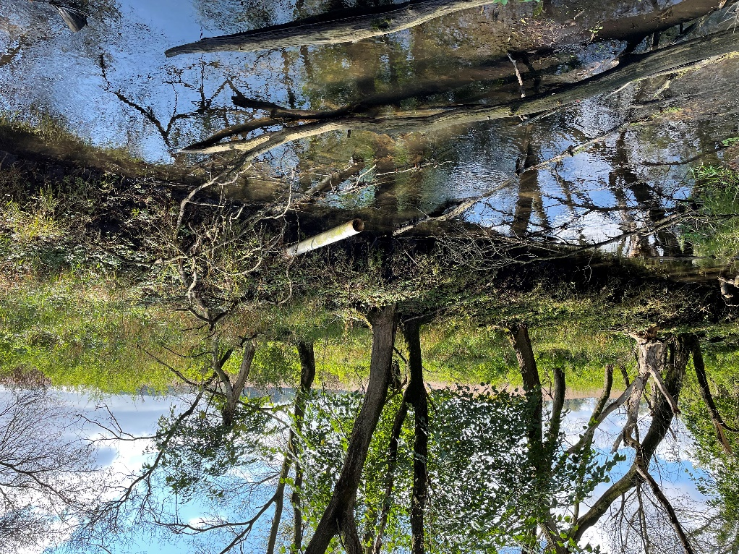
Figure 1: Current Conditions Taken from the LRMD Preserve Featuring a Drainage Pipe from Neighboring Farms Dumping into the Inlet Stream

1.2 Site Alternatives
BPS is evaluating three proposed alternative designs that meet the project goals outlined by LRMD. These design alternatives include:
- Alternative 1 – Alternative 1 requires the excavation of a new stream that would meander through the Lake District Preserve eliminating the need for the existing channel downstream of the intervention point. Flow would be redirected at the point where the stream crosses into LRMD property, and after meandering through the wetland, the newly excavated stream would meet the existing channel again where the existing stream reaches LRMD property once again. Creating a new stream channel would allow customization of stream banks to encourage flooding of the wetland to see maximum purification of surface water.
- Alternative 2 – Alternative 2 details the development of a berm and diversion across and on the north side of the stream where it crosses into LRMD property. This berm will redirect flowing water from the stream onto LRMD property where it will disperse through the Lake District Preserve via several small, excavated channels and travel through the wetland before reaching Lake Ripley.
- Alternative 3 – Alternative 3 involves the installation of a weir in the Lake Ripley influent stream just west of Co. Rd. A where the stream crosses into LRMD property. The weir is designed to raise the stage of the stream by several inches. This increased stage will encourage flooding of the stream during rainfall events allowing excess surface water to overflow into the LRMD wetland and be stripped of phosphorus and nitrogen while settling suspended solids before reaching Lake Ripley. The streambank will be graded upstream of the weir to encourage water to overflow onto the LRMD-owned streambank towards the wetland scrape.

1.3 Design Constraints
Design of the watershed improvement for Lake Ripley is limited by various constraints across several categories. These include economic, environmental, social, political, ethical, health and safety, manufacturability, and sustainability constraints. The constraint that has limited preliminary design most is the project location constraint. Construction is limited to LRMD property, and there are only small sections of the influent stream that cross into this area as it exists today, see Figure 1. Engineering manipulations must be made to these small sections to achieve project goals.
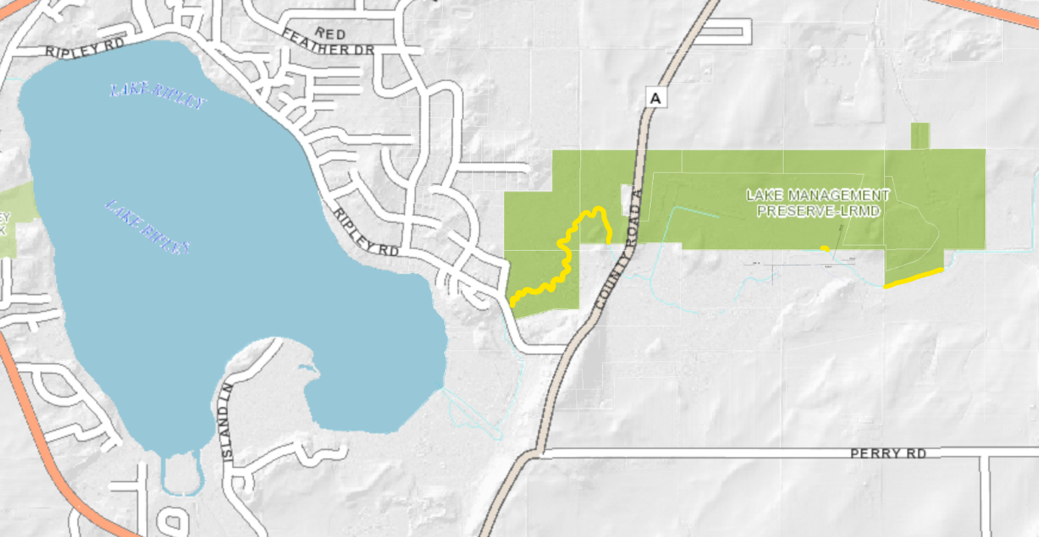
Figure 2: View of the LRMD preserve with respect to Lake Ripley - stream areas that can be affected by LRMD are highlighted in yellow

1.4 Evaluation of Site Alternatives
BPS analyzed each of its three proposed design alternatives against ten criteria. These included: construction cost, labor, environmental impact, expected area of flow impact, volume of water redirected by design, construction time frame, permitting required, heavy equipment needs, social justice, and long-term maintenance. Each criterion was assigned a weight that represents its value to the overall project. These weights were discussed between team members and extensively with LRMD representatives. The decision matrix indicates that the excavation of a new channel, Alternative 1, is the best alternative.

1.5 Estimate of Probable Cost
BPS has provided an initial cost estimate for the proposed watershed improvements for Lake Ripley. Due to current data and knowledge-based uncertainty on existing site conditions, this estimate is subject to uncertainty as well and will likely change as more information is obtained during the final design process. After analyzing each proposed alternative, Alternative 1 has an estimated project cost of $244,000. Alternative 2’s project cost is estimated at $282,000, and Alternative 3 has an estimated project cost of $328,000.

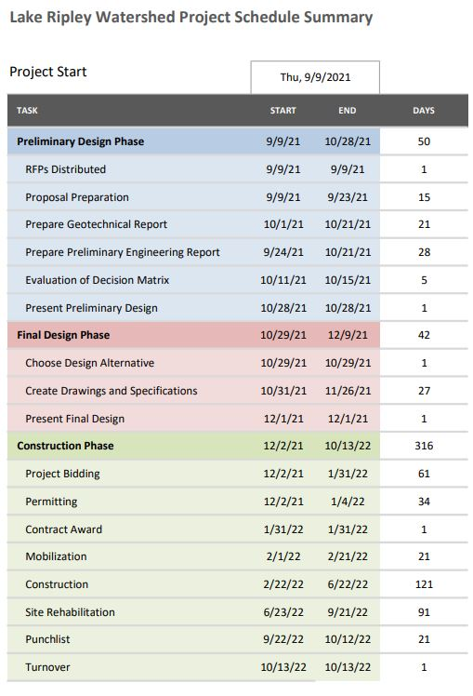
1.6 Project Schedule
The project schedule has been broken down into two main phases, the design phase and the construction phase, with the design phase being further broken down between preliminary and final design. The total duration for the design phase of the project is 59 working days, and its activities include all necessary pre-construction document preparation and calculations. The project will go out to bid on December 2nd of 2021, and contractors will have 60 days to review the contract drawings, submit RFIs, and prepare a bid. Mobilization will occur as soon as the contract is awarded, and construction activities are expected to start on February 22nd of 2022. After earthwork and excavation activities are complete, a thorough restoration effort will take place to ensure that construction does not have lasting negative impact on the natural beauty of the preserve or the health of its inhabitants. The project is planned to be turned back over to the LRMD by October 13th of 2022.

Figure 3: Summary of project schedule
Table of Contents
DISCLAIMER: Student Project Documents 2
1.0 Executive Summary 3
1.1 Project Description 3
1.2 Site Alternatives 3
1.3 Design Constraints 4
1.4 Evaluation of Site Alternatives 4
1.5 Estimate of Probable Cost 5
1.6 Project Schedule 5
2.0 Project Overview 9
2.1 Introduction 9
2.2 Project Backgrounds and Needs 9
2.4 Project Constraints 10
2.4a Economic 10
2.4b Environmental 11
2.4c Social 11
2.4d Political 12
2.4e Ethical 12
2.4f Health and Safety 12
2.4g Constructability 12
2.4h Sustainability 13
2.4i Pertinent Regulatory Codes and Professional Standards 13
3.0 Existing Site Conditions 13
3.1 Transportation 13
3.2 Construction Requirements 15
3.3 Utilities 15
3.4 Soils 16
4.0 Design Alternatives 16
4.1 Alternative 1: New Channel Excavation 16
4.2 Alternative 2: Berm and Diversion 17
4.3 Alternative 3: Weir 18
5.0 Alternative Comparison 18
5.1 Alternative 1: New Channel Excavation 18
5.1a Hydrology 18
5.1b Geotechnical 19
5.1c Environmental 19
5.1d Surveying/Geospatial 19
5.2 Alternative 2: Berm and Diversion 19
5.2a Hydrology 19
5.2b Geotechnical 19
5.2c Environmental 19
5.2d Surveying/Geospatial 20
5.3 Alternative 3: Weir 20
5.3a Hydrology 20
5.3b Geotechnical 20
5.3c Environmental 20
5.3d Surveying/Geospatial 20
6.0 Final Alternative Recommendation 20
6.1 Construction Cost 21
6.2 Labor Requirements 21
6.3 Environmental Impact 21
6.4 Flow Area of Impact 22
6.5 Volume of Water Redirected 24
6.6 Construction Time Frame 24
6.7 Permitting Required 24
6.8 Heavy Equipment Needs 24
6.9 Social Justice 25
6.10 Long Term Maintenance 26
7.0 Opinion of Probable Costs 26
8.0 Project Schedule 29
9.0 Social Sustainability 29
9.1 Economic 29
9.2 Environmental 29
9.3 Safety 29
9.4 Social 30
10.0 Uncertainties 30
10.1 Data-Based Uncertainty 30
10.2 Knowledge-Based Uncertainty 30
10.3 Uncertainty in Estimate of Probable Cost 30
11.0 Recommendations and Conclusion 31
Appendix 32
Calculations 32
Figures 33
Tables 35

Table of Figures
Figure 1: Current Conditions Taken from the LRMD Preserve Featuring a Drainage Pipe from Neighboring Farms Dumping into the Inlet Stream 3
Figure 2: View of the LRMD preserve with respect to Lake Ripley - stream areas that can be affected by LRMD are highlighted in yellow 4
Figure 3: Summary of project schedule 5
Figure 4: Aerial View of Lake Ripley, the Surrounding Watershed, and the Management District 10
Figure 5: Distance Between LRMD Preserve and Town of Oakland Town Hall 14
Figure 6: Existing Site Access Road Through LRMD Preserve 14
Figure 7: Site Access Plan for Weir Construction 15
Figure 8: Soil Boring from Geotechnical Report 16
Figure 9: Proposed Excavated Channel for Alternative 1 17
Figure 10: Proposed Berm Location for Alternative 2 17
Figure 11: Proposed Weir Location for Alternative 3 18
Figure 12: Expected Area of Flow Impact for Alternative 1 22
Figure 13: Expected Area of Flow Impact for Alternative 2 23
Figure 14: Expected Area of Flow Impact for Alternative 3 23
Figure 15: Depiction of properties that will be impacted with alternatives 1 and 2 25
Figure 16: Depiction of properties that will be impacted with alternative 3 26

Tables
Table 1: Decision Matrix to Select Final Proposed Alternative 21
Table 2: Proposed Cost Estimate for Alternative 1 27
Table 3: Proposed Cost Estimate for Alternative 2 28
Table 4: Proposed Cost Estimate for Alternative 3 28

Table of Appendix Details
Appendix 1: Historic Phosphorus levels in the influent stream as compared with the DNR quality level of allowable phosphorus (0.075 mg/L) 33
Appendix 2: Historical Seasonal Snowfall in the Greater Madison Area 34
Appendix 3: Historical Annual Precipitation in the Greater Madison Area 34
Appendix 4: Wet Prairie 10 Acre Preserve Seed Mix – from LRMD 35
Appendix 5: Tall Grass Prairie Seed Mix – from LRMD 35
Appendix 6: Mesic Prairie 45 Acre Preserve Seed Mix – from LRMD 36
Appendix 7: Art Kitchen Native Grass Prairie Seed Mix – from LRMD 36
Appendix 8: 2006 LRMD point intercept survey showing relative frequencies of aquatic plants in Lake Ripley 37
Appendix 9: 2020 LRMD point intercept survey showing relative frequencies of aquatic plants in Lake Ripley 38

2.0 Project Overview

2.1 Introduction
Beaver Professional Services (BPS) has been tasked by the Lake Ripley Management District (LRMD) to evaluate and compare the three proposed alternatives for rerouting the Lake Ripley inlet stream. This project will change the stream flow and allow a new flood area to increase the residence and settling time of the stream. As a whole, the project is designed to build upon the current natural beauty of the LRMD preserve while also protecting the existing wetland and prairie environments. This alteration will lead to improved water quality in Lake Ripley through the reduction of phosphorus, nitrogen, and suspended solids in the influent water.

2.2 Project Backgrounds and Needs
The purpose of the inlet redirection in Cambridge, Wisconsin is to provide a higher quality of water in Lake Ripley for the locals and visitors who use the lake but also for the ecosystem that is working to survive within the lake. As an added benefit to this proposal, each of the alternatives that were generated would increase the level of flooding within the LRMD preserve – which would help flush out invasive plant species that are not as flood-tolerant as the native seed bank. Cambridge has a storied culture that began with the town’s founding one year before the state of Wisconsin was founded – in 1847. The downtown area boasts shops and boutiques to satisfy any need, and the natural surroundings incorporate a great system of trails throughout the village. This cultural space lends itself nicely to a project that is working to improve the natural resources of the village. Cambridge pride comes from the fact that this village provides the kind of “small town getaway in the Midwest” ambiance that tourists love and seek out. The construction of this project would enhance the natural options that contribute to that goal. Of course, not every citizen is expected to view the project favorably. BPS strives to deliver a socially, economically, and environmentally sustainable solution that would maintain the current quality of the nature preserve while also enhancing the quality of Lake Ripley itself. In an effort to attain this goal, BPS anticipates hosting town hall events, in-person or virtually, in order to hear from the general public as the project progresses from design into construction.
The preliminary design process can be broken up into four phases: site understanding (site visit), alternative brainstorm, alternative selection, and design of alternatives. BPS has been in frequent communication with the client contact, Lianna Spencer: District Manager, in order to clearly establish what the requirements and expectations are for each phase so that the final design alternatives meet what she, and the LRMD, desire while also being practically sound. In terms of scope, two of the alternatives are much larger in scope of excavation or disruption to the wetland environment, a criterion that LRMD values. But one of those alternatives could also affect a much larger volume of water, which is the main driver of this project overall. In order to balance these difficult and occasionally oppositional ideas, BPS evaluated each alternative on the basis of the criteria below:
- Construction cost
- Labor
- Environmental impact
- Expected area of impact when redirected
- Volume of water redirected
- Construction time frame
- Permitting required
- Heavy equipment needs
- Social justice
- Long term maintenance
The first section of this report is dedicated to evaluating each alternative based on categories related to environmental, geological, hydrological, and surveying and geotechnical engineering analyses. One alternative will be recommended based off the decision matrix that was developed by the BPS team following the ten criteria listed above. Each alternative meets a threshold expectation for environmental impact – none irreparably degrades the surrounding environment, and all have an impact on the influent stream.

2.4 Project Constraints

2.4a Economic
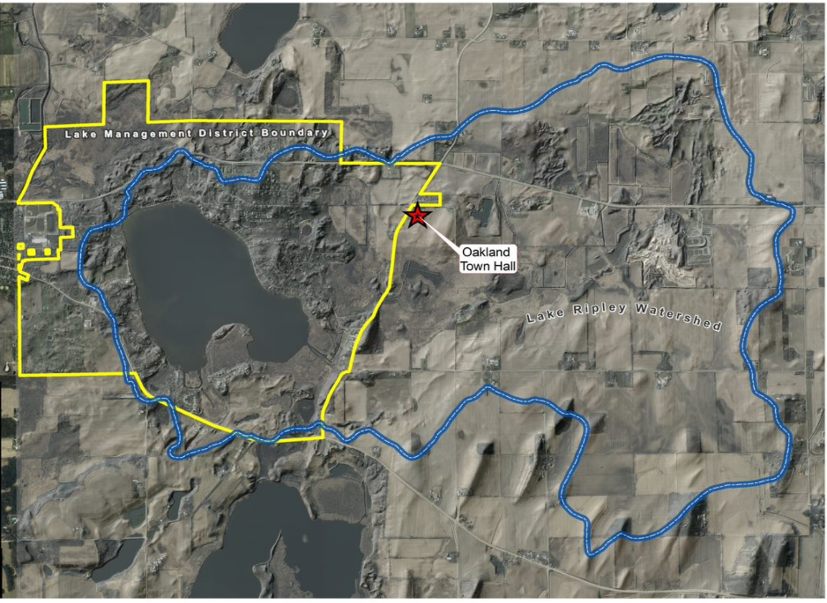
The economic components of this project are limited by the income that the LRMD is able to access and distribute. As documented in the Approved 2020 LRMD Budget, the vast majority of the district’s income comes from a Real Estate Tax Levy on the almost 2,000 houses around Lake Ripley within the Lake Management District Boundary, see Figure 4 for aerial view. The LRMD is a local special-purpose unit of government and works diligently to serve its constituents. There is no set construction plan as of yet, but it is in the client’s, and the public of Oakland’s, best interest to minimize the cost in order to respect and extend the taxpayer dollars dedicated to the project. Potential costs of the project include transportation and equipment access, land grading and rehabilitating, and potential permits to acquire for wetland excavation. Each alternative needs to be evaluated not only in consideration of the feasibility of implementation and environmental impact, but also in their lifecycle costs.
Figure 4: Aerial View of Lake Ripley, the Surrounding Watershed, and the Management District

2.4b Environmental
Environmental considerations are arguably the most pressing criteria for this project. This is due to the nature of the project itself, the whole reason that BPS was hired to reroute this inlet stream was in order to improve the water quality of Lake Ripley by removing the phosphorus and suspended solids in the stream. Additionally, the environmental aspects were emphasized by the LRMD to be the highest priority consideration in meetings with BPS in order to preserve the wetland and prairie environments that the stream travels through. Given the location of the project, multiple DNR permits would be required including wetland disturbance for recreational development (GP4) and Utility wetland, bridge, structure, dredging, driving on the bed (GP3) to name two. After much consideration, BPS was able to determine that this engineering project could not be solved by not disrupting the current ecosystem at all. Instead, the team focused on only impacting the surrounding environment in a positive manner – making change in order to accomplish a task to better the health of the preserve. Each alternative requires varied levels of excavation, but all require some excavation. In order to reduce the negative impacts brought on by disrupting the ecosystem, BPS has evaluated each alternative with winter construction in mind. While this decision would require more construction equipment, as the excavating could not be done by hand in the frozen ground, it would also lessen the impact on the local ecosystem because the stream would be frozen, and the solidified soil would support the heavy machinery better without sustaining damage. All three alternatives require no tree removal as there is an existing access road that allows the necessary construction equipment to reach the site of excavation through the preserve, and the weir excavation site is easily accessible from Highway A – see Figure 6 & Figure 7 for visual reference. One benefit is that between the three alternatives, there is only one proposed permanent fixture, the weir. Weirs are designed to go into waterways without harming the stream itself, so all structures are already ready to be implemented towards redirecting the stream flow without negatively impacting the existing environment. Lastly, LRMD is looking to eliminate some existing invasive species in the prairie that surrounds the stream bed and the increased flooding of that area that is proposed in all three alternatives has been shown to help eliminate the Reed Canary Grass that has infiltrated the preserve.

2.4c Social
As a civil engineering firm BPS prioritizes the public’s needs and opinions because even though not everyone in the Town of Oakland or the Lake Ripley Management District will know about the proposed construction or be directly impacted by the process, everyone in the area can witness the changes that are implemented in the public sphere. The preserve itself will change as the stream that runs through it has changed the landscape, so any people that frequent the paths there will have a different view. And the proposed alternatives are designed to limit the amount of phosphorus and suspended solids that enter into Lake Ripley. These changes to water quality would lead to increased water clarity and decreased algal blooms in the lake – which would be noticeable to anyone who uses the lake for work or recreation. A winter construction schedule is being considered in order to limit the impact that the construction would have on the public and public opinion as well. The lake and the preserve are used most frequently in the warm months of the year, thus construction in winter would lead to the smallest interruption of public usage for the land. Each option would affect the landowners whose properties abut the preserve. Alternatives A and B would greatly reduce or eliminate the flow that reaches neighboring properties as the water is diverted into the preserve while alternative C would increase the flow level upstream of the weir. As directed by LRMD BPS is currently working under the assumption that the local property owners are supportive of any changes that would be made to stream flow. BPS will continue to collaborate with LRMD in order to address any social concerns that are raised as the project progresses through the design phase into the construction of the selected alternative.

2.4d Political
The client of this project is the LRMD, and the goal is to serve the general public by improving the overall water quality in Lake Ripley. That being said, BPS acknowledges that there are many stakeholders who will be affected by the project both directly and indirectly. This project will be funded by taxpayer dollars paid to the LRMD, and as such BPS will continue to work with LRMD to make sure that the public is supportive of any alternative that is selected. Additionally, as the LRMD evaluates the alternatives, BPS will participate in a town hall hosted in order to hear the comments and concerns of the citizens of Oakland with respect to this project. Lastly, BPS will work with the Wisconsin Department of Natural Resources (WDNR) in order to obtain the necessary permits in an appropriate time frame for construction.

2.4e Ethical
BPS holds an ethical commitment not only to the client, the LRMD, but also to the public in the Town of Oakland and beyond, along with the other staff members who work on the project. Throughout the design and construction processes BPS will deliver results that adhere to the standards of ethics as set by the National Society of Professional Engineers (NSPE) and the American Society of Civil Engineers (ASCE). Please see the NSPE Fundamental Canons that will BPS engineers will uphold:
- Hold paramount the safety, health, and welfare of the public
- Perform services only in areas of their competence.
- Issue public statements only in an objective and truthful manner.
- Act for each employer or client as faithful agents or trustees.
- Avoid deceptive acts.
- Conduct themselves honorably, responsibly, ethically, and lawfully so as to enhance the honor, reputation, and usefulness of the profession.

2.4f Health and Safety
The site of excavation is on the LRMD preserve, but it is close to the house of an adjacent property. The most pressing issue to consider during planning and construction is the protection of the prairie and wetland ecosystems that surround the stream, and steps such as swamp mats and winter construction have been planned for in order to limit the impact as much as possible. Additionally, BPS will eliminate public health and safety hazards that may arise during construction. Lastly, BPS will continue the record of adhering to OSHA policy on every jobsite in order to ensure that the worker and public health is not jeopardized in any way. The on-site team will encourage the safest construction site possible by following every safety procedure and posting said procedures in a location that all employees can access if needed.

2.4g Constructability
BPS recognizes the construction constraints that come with excavating in a nature preserve. While each alternative requires a relatively small section of disturbed land, adequate access points and roadways are not only required but also must be equipped for heavy construction equipment. Winter construction will help with limiting the destruction of the soil structure that the access road must travel, but BPS must be prepared for any additional project constraints that may arise as well.

2.4h Sustainability
Sustainability is a key tenet for Beaver Professional Services, which is one of the many reasons why the team was so excited to take on this project for the LRMD. BPS will deliver a final design that is economically, socially, environmentally, and politically sustainable for years to come – one of the criteria considered when making the final recommendation was the level of long-term maintenance that is required. The goal for this project is to maximize the taxpayers’ dollars in order to affect the most positive change on the Lake Ripley Watershed in order to provide for the well-being of future citizens of the Town of Oakland. If the water quality of Lake Ripley improves, the lake will be a sustainable center of community and recreation well into the future. BPS will take any public opinion about the proposed changes into consideration in order to acknowledge those concerns and limit public resistance to the project. Overall, the final stream redirection design will try to preserve the natural ecosystems around the stream as much as possible while also making changes to the stream path that will benefit the surrounding prairie, wetland, and lake downstream.

2.4i Pertinent Regulatory Codes and Professional Standards
BPS will follow and adhere to any local, state, or federal regulatory codes that may apply to this project throughout the process of designing and proposing alternatives. The relevant regulatory codes and professional standards include, but are not limited to:
- Town of Oakland local zoning and building permits
- WDNR: Wetland disturbance - recreational development (GP4) and Utility wetland, bridge, structure, dredging, driving on the bed (GP3)
- Wisconsin NR 11, 106, and 151

3.0 Existing Site Conditions

3.1 Transportation
Situated an hour West of Milwaukee and a half hour East of Madison, the LRMD Preserve is located at N4341 County Road A in Cambridge, Wisconsin. County Road A is lightly trafficked and is in close proximity to Interstates I-94 and I-90, allowing for a smooth route for construction deliveries. The preserve features a small parking lot which will likely be used for site parking. Overflow parking will take place a half mile North of the preserve in the Town of Oakland Town Hall. The distance between the LRMD preserve and the town hall is pictured in Figure 5. To maintain the natural beauty of the preserve throughout the duration of the project, access roads shall not be developed to accommodate construction activities. There is an unpaved access road that skirts the North border of the preserve and loops near the main construction area. This will be sole route for access to the main construction area. However, the access road will not be able to accommodate larger flatbed trucks or semis, so construction deliveries will need to be adjusted accordingly. This access path is shown in Figure 6. For Weir construction outlined in Alternative 3, access is detailed in Figure 7.

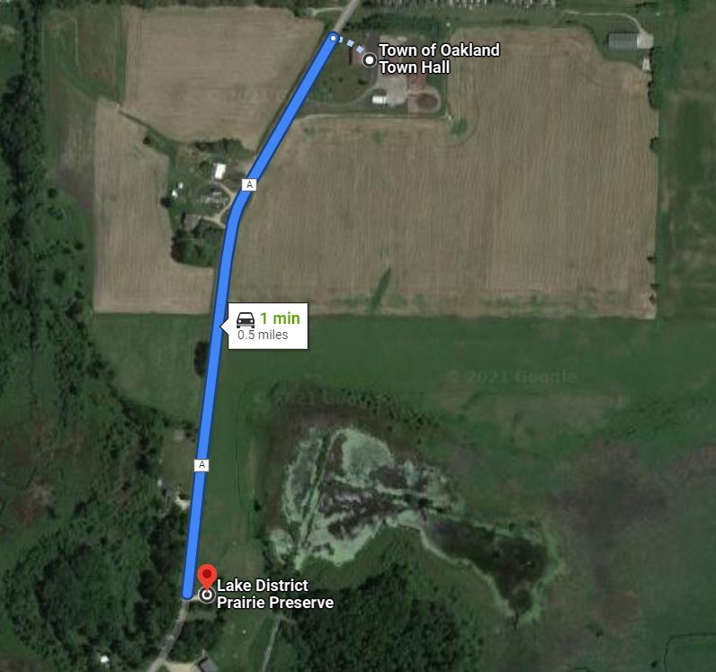
Figure 5: Distance Between LRMD Preserve and Town of Oakland Town Hall
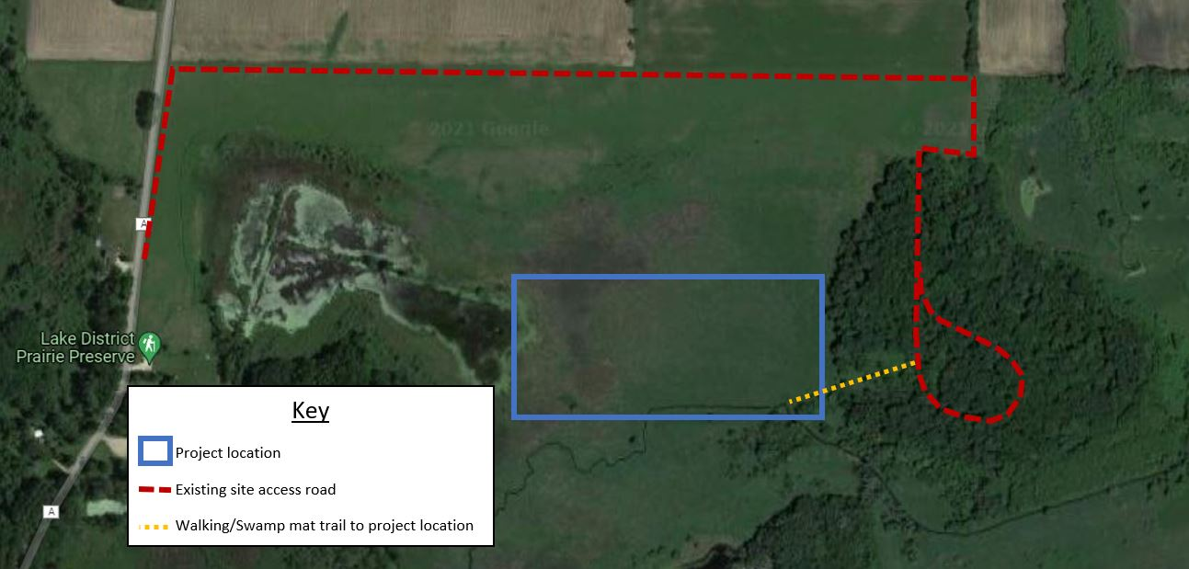
Figure 6: Existing Site Access Road Through LRMD Preserve

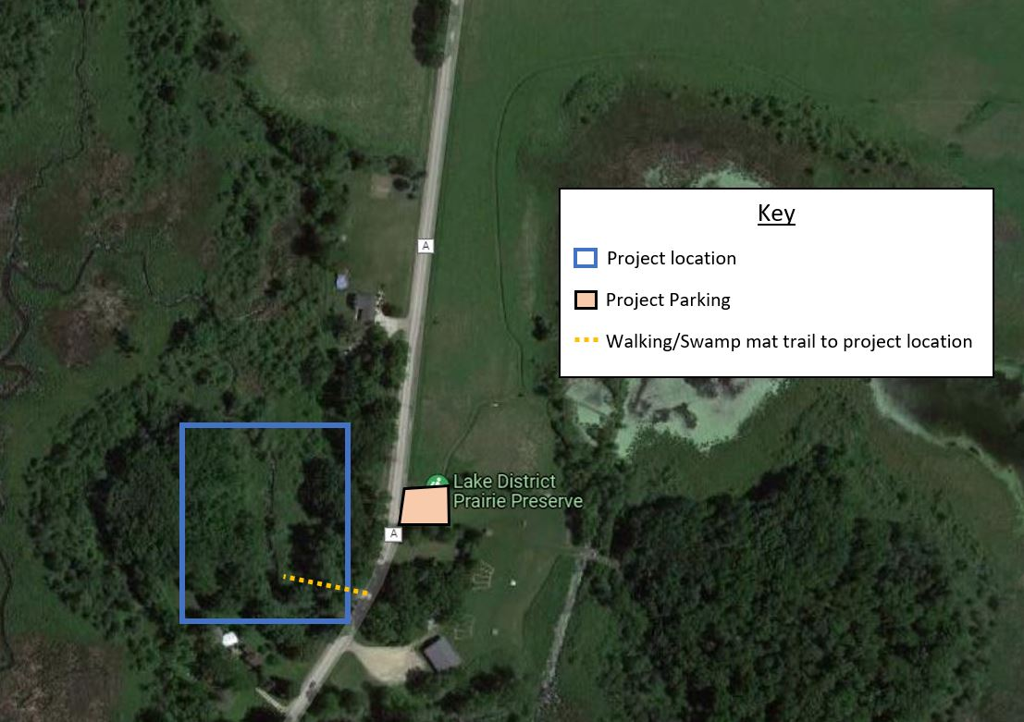
Figure 7: Site Access Plan for Weir Construction

3.2 Construction Requirements
Construction in the Preserve will be dictated by the environmental concerns and disturbance requirements outlined by the LRMD as well as Wisconsin DNR requirements for construction in designated wetlands and navigable waterways. Construction activities are not to disturb the natural beauty of the preserve, meaning that large excavating equipment should be avoided, if possible, during construction. Most of the project site is DNR designated wetland. Equipment staging and material layout areas are not to be in any wetland region to avoid water damage, and the use of swamp mats, or other protective ground coverings, are encouraged during construction. Manual labor will be preferred to the use of machinery for detailed excavation of the project alternatives, so the contractor should be prepared to provide alternate labor numbers in their bid to show cost impact of additional labor required to execute the project without using traditional excavating equipment. Weir construction falls under the Wisconsin DNR’s dam construction requirements.

3.3 Utilities
The project area features neither above or below ground utilities that would inhibit site access or excavation. The only underground hazards in the streambank area are drainpipes that flow into the stream from adjacent farm fields (see Figure 1). However, all such pipes are upstream of the area where construction would occur. Despite the BPS team’s best efforts to identify below ground construction hazards, make sure to call Digger’s Hotline before excavation begins. They can be reached at (800) 242-8511. Water in this municipality is provided by the Cambridge Water and Sewer Utility (608) 423-3712. Electric and gas is supplied by Alliant Energy, and their local office number is (608) 423-4827.

3.4 Soils
A geotechnical report was conducted in conjunction with this report to analyze subsurface conditions in the project area. In this report, five soil borings were gathered using hollow stem augers, and the depth of each boring was thirty feet. The findings of these borings are summarized in Figure 8, and the specific boring profiles can be seen in the BPS’s geotechnical report for this project. Water table height was found to be at an average depth of 2-3 feet. The bulk of work will take place in the upper layer of sandy clay topsoil, creating a potentially unstable environment for larger equipment. Due to these unstable surface conditions, BPS is recommending all construction activities requiring heavy equipment to be executed during the Winter months, when the ground is frozen, so that soil conditions are at their most stable. If using heavy machinery when the soil is thawed, BPS recommends using a swamp mat or another wetland construction method to ensure safe use of equipment.
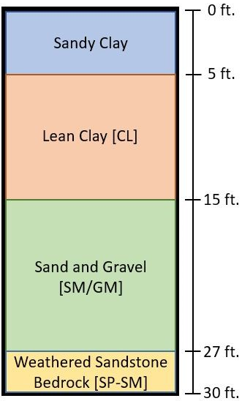
Figure 8: Soil Boring from Geotechnical Report

4.0 Design Alternatives
After analysis of existing site conditions and multiple site visits to understand the scope of the project, the BPS team performed research to determine possible design alternatives that would improve the water quality of Lake Ripley. Research performed was narrowed down to three design alternatives that will be compared to select one design to proceed with for the final design phase.

4.1 Alternative 1: New Channel Excavation
Channelizing a new stream is the first proposed alternative to improve water quality of Lake Ripley. A small excavator will be used to develop a new channel that diverts from the existing stream on the south side of the Lake District Preserve where the stream meets the LRMD property line. The channel will have gentle 1:4 sloped banks and will meander through the preserve until it hits the wetland scrape to the west. An existing channel from the wetland the existing stream channel will provide an outlet for water to continue flowing towards Lake Ripley. The flow path of the new channel is laid out in Figure 9.
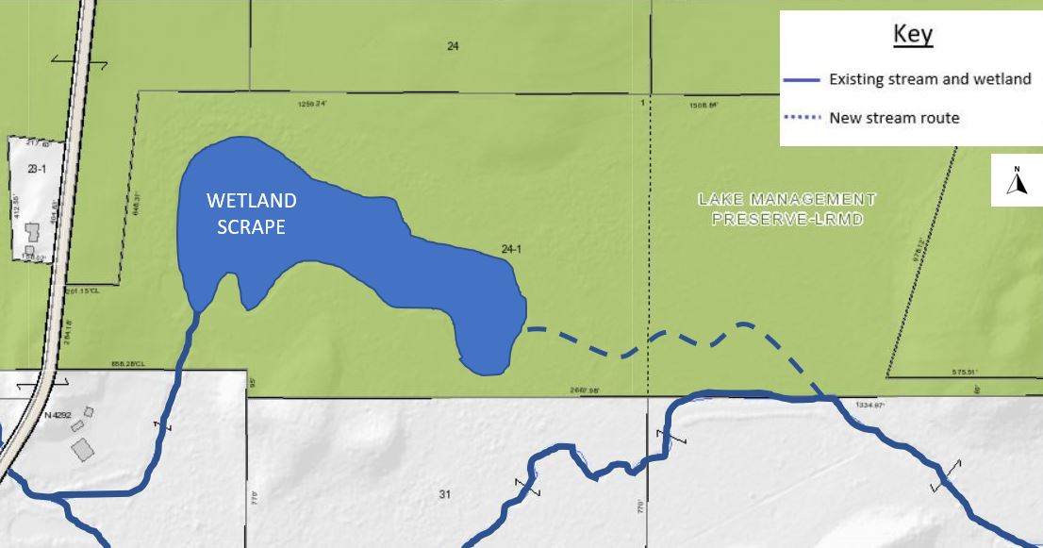
Figure 9: Proposed Excavated Channel for Alternative 1

4.2 Alternative 2: Berm and Diversion
The second proposed alternative involves creating a diversion on the south side of the Lake District Preserve where the influent stream reaches LRMD’s property line. This diversion will block flow from continuing through the existing channel. This flow will be diverted to a short stretch of new channelization, and a berm on the north side of the stream bank will prevent water from immediately flowing back into the existing stream. The short new channel will follow a similar path as Alternative 1, but once the channel reaches a point in the Lake District Preserve, flow will dissipate into the preserve via several fingers that will extend from the new channel. A schematic of flow for Alternative 2 is shown in Figure 10.
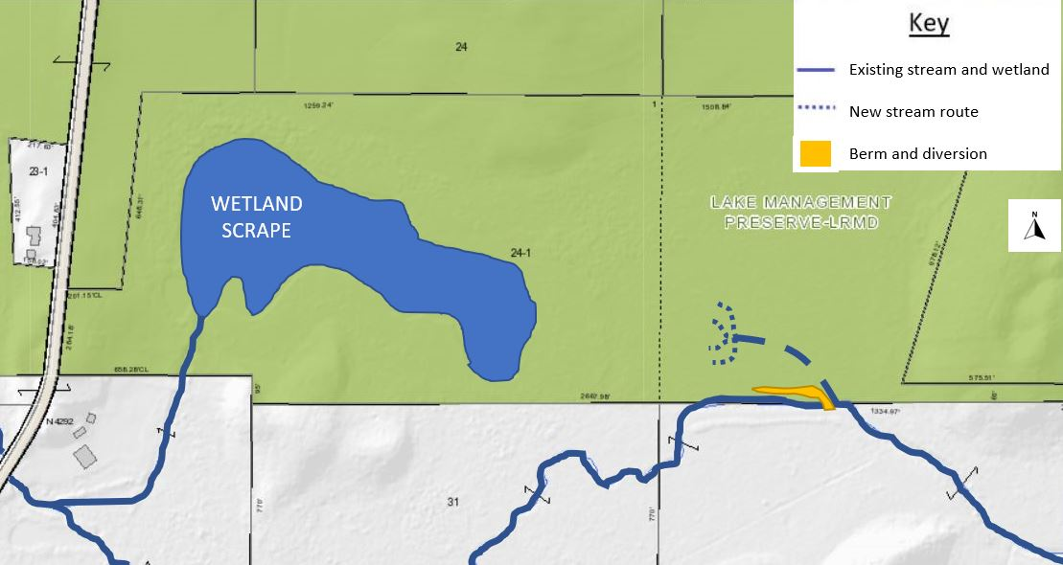
Figure 10: Proposed Berm Location for Alternative 2

4.3 Alternative 3: Weir
The third design alternative proposes that a weir be installed on the west side of the Lake District Preserve just downstream of where the stream crosses Co. Rd. A as detailed in Figure 11. A prefabricated outlet control weir wall will be installed at the designated weir location. This weir will be 6 inches tall and will displace 36.8% of the existing stream’s cross-sectional area of flow resulting in stream depth increase by 5.1 inches to 20.7 inches or 1.725 ft and a stage increase to an elevation of 842.425 ft at our project location. At the point upstream of the weir where the stream is adjacent to LRMD property, the streambank will be graded to encourage water to overflow into the Lake District Preserve following high rainfall events.
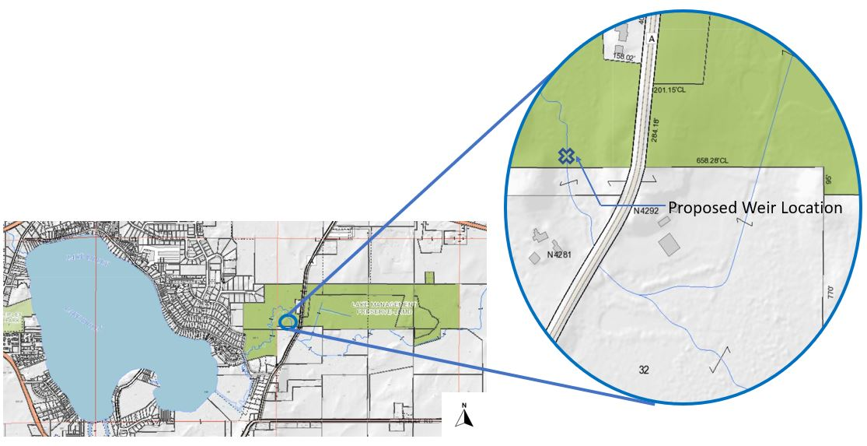
Figure 11: Proposed Weir Location for Alternative 3

5.0 Alternative Comparison
Analyzing the qualities of each design alternative against a variety of criteria is critical to the determination of a final design alternative. In this section, all three alternatives will be compared through the four engineering focus areas the BPS team focused its design on: hydrology, geotechnical, environmental, and surveying/geospatial engineering. This comparison will display the key design differences between each alternative, and in the following section, “6.0 Final Alternative Recommendation”, the comparison between alternatives will be quantified into a design matrix that will be used to select the final design recommendation.

5.1 Alternative 1: New Channel Excavation

5.1a Hydrology
Excavation of a new channel is an efficient way to perform complete redirection of flow from the existing stream channel to the newly excavated channel. The newly excavated channel will be dug to an elevation of 840 ft with 1:4 sloped banks. The shallower nature of the stream will allow for lower streambanks and encourage interaction of flow with native species in the preserve. With minimal elevation drop between the point of intervention and the entrance to the preserve wetland, flow velocity will decrease from its existing level in the influent stream to allow for settling of suspended solids in the stream.

5.1b Geotechnical
Alternative 3 requires the use of an excavator to dig the new channel as well as a truck that can hold displaced soil to be redirected to other locations on the preserve. Access to the construction site will be routed through existing access road on a forested area and then via temporary access roads that will be implemented into the project site. The 75% geotechnical report details the impact that heavy equipment in this design has on existing geotechnical conditions. The footprint of the 30,000 lb. excavator used is 100 sq. ft. This falls within the allowable bearing capacity of 3310 psf at 300 psf. In addition, construction will occur while the ground is frozen to further limit destruction of existing geological conditions.

5.1c Environmental
The excavation of a new stream channel will redirect 100% of flow from the existing stream into the Lake District Preserve. Once the excavated stream reaches the wetland, water will be free to disperse through the wetland to maximize interaction with native species that can strip phosphorus and nitrogen from the water. Flooding of the wetland in this way will also have positive impacts on the control of Reed Canary Grass in the wetland which is a species that is controlled well with periodic flooding.

5.1d Surveying/Geospatial
To complete excavation of a stream into the Lake District Preserve, the 840 ft. elevation of the wetland will be pulled east to the point of intervention which is lower than the stream elevation of approximately 842 ft. This will provide a head drop that increases velocity of flow briefly and encourages all flow to redirect into the new channel.

5.2 Alternative 2: Berm and Diversion

5.2a Hydrology
The berm and diversion alternative, similarly to Alternative 1, redirects all flow in the influent stream by introducing a blockage of the stream and grading north streambanks to encourage overflow of the stream into the preserve. Overflow into the preserve will travel through the preserve toward the wetland without the presence of a consistent channel. Velocity of flow will decrease even more so than in Alternative 1 which will allow for increased residence time in the preserve and increased settlement of suspended solids.

5.2b Geotechnical
Alternative 2 requires the same use of an excavator and truck for removal and transport of displaced soil as Alternative 1; however, this equipment will not need to travel as far into the Lake District Preserve as would be needed in Alternative 1. This reduces the geological impact and settlement that will result from construction of the design alternative. The berm and diversion alternative will use the same excavator as Alternative 1 that falls within the allowable bearing capacity but over a smaller area of impact because there is less distance to travel into the preserve.

5.2c Environmental
The berm and diversion environmental impacts will act very similarly to Alternative 1 in that 100% of flow will be redirected into the preserve and will reach the wetland for purification treatment. Alternative 2 will have added benefits because of its slower velocity through the preserve. Its longer residence time will allow for a lengthier purification and further stripping of phosphorus and nitrogen from the water before it returns to the join the existing stream to Lake Ripley.

5.2d Surveying/Geospatial
Alternative 2 involves grading out the stream bank north of the berm and diversion so that a slow elevation drop will occur from the intervention point at 842 ft. to the wetland entrance of 840 ft. This slow drop traveling over the preserve will keep flow velocities low for longer residence time.

5.3 Alternative 3: Weir

5.3a Hydrology
The installation of a weir in the influent stream will increase the stage of the stream upstream of the weir by 5.1 inches as detailed in calculations in the Appendix. This increased stream stage will work together with planned grading of the streambank to encourage overflow during high rainfall events to run into the preserve. Once in the preserve, flow will travel in a dispersed manner similarly to Alternative 2. This will result in low velocity flow that allows for the settlement of suspended solids from the stream.

5.3b Geotechnical
Alternative 3 has increased impact on geological conditions because equipment will need to be used in two different locations. The excavator and truck for soil will still be needed at the location of streambank grading in addition to an excavator and crane at the site of the weir installation. Equipment will be able to access the weir installation location just adjacent to Co. Rd. A. Settlement will occur in both locations. At the site of streambank grading, soil conditions remain like those of Alternatives 1 and 2. A 30,000 lb excavator will be used and will impose a load 300 psf which falls within the allowable bearing capacity of the site, 3310 psf.

5.3c Environmental
Following Manning’s Open Channel Flow calculations provided in the Appendix, 36.3% of the existing stream’s cross-sectional area will be displaced by the selected prefabricated weir. This 36.3% of the cross-sectional area will raise the stage of the stream by 5.1 inches that is expected to overflow at the point where the streambank is graded to allow for overflow into the preserve. There is less opportunity in this alternative for stripping of phosphorus and nitrogen because less flow is redirected into the preserve for interaction with the native wetland species.

5.3d Surveying/Geospatial
The streambank north of the existing inlet stream will be graded to reduce the height of the existing streambank from 842 ft. closer to the elevation of the wetland entrance of 840 ft. to encourage flow to spill into the preserve during high rainfall events.

6.0 Final Alternative Recommendation
A decision matrix was developed to evaluate the three proposed design alternatives. Each step of the matrix calculation can be viewed in the Appendix. Table 1 summarizes the decision matrix results. A weight was assigned to each criterion of consideration. The criterion and their weights were determined per discussions with LRMD representatives. After completion of the decision matrix evaluation, Alternative 1, the new channel excavation, is the most effective alternative to accomplish all the of the qualities that LRMD is seeking in a solution.
Table 1: Decision Matrix to Select Final Proposed Alternative
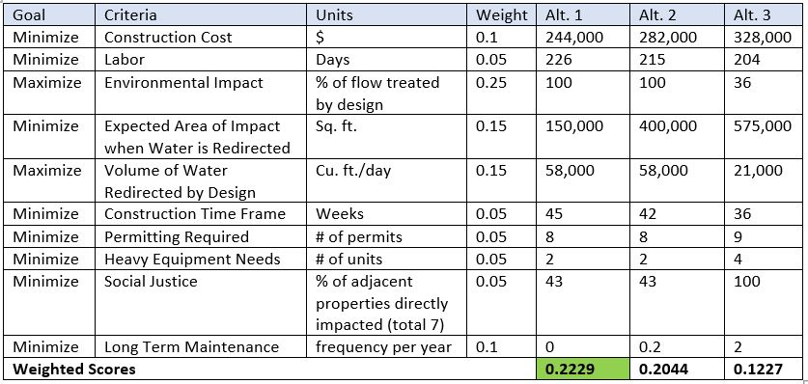

6.1 Construction Cost
Construction cost estimates are itemized and detailed in section “7.0 Opinion of Probable Costs”.

6.2 Labor Requirements
Labor requirements are closely tied to the construction timeline portion of this analysis, which is located in section 6.6 of this report. Alternative 1 is predicted to require the most labor due to the length of excavation and the associated restoration efforts that will accompany it. A total of 226 working days are estimated for this option. Alternative 2 is estimated to require slightly less labor because the amount of excavation is less than that of Alternative 1. Even though the intricate excavation techniques required for this project will bring its duration closer to that of the first option, Alternative 2 is estimated to require 215 working days. Alternative 3, although requiring additional and specialized labor to install the weir, is estimated to require only 204 days of labor. This is because the excavation scope of this option is so much less than that of the other two.

6.3 Environmental Impact
Alternatives 1 and 2, the channel excavation and the berm and diversion respectively, each utilize 100% of the influent stream flow in their design by blocking off the existing channel downstream of the point of intervention. All flow from these two designs will be treated through the preserve wetland before joining the existing channel again to exit Lake Ripley. These designs are where the most phosphorus removal and suspended solid removal will be observed due to complete treatment of flow.
Alternative 3, weir installation, will raise the existing stage of the stream by 5.078 inches according to calculations found in the Appendix. The flow of water above the existing stage is what will be diverted into the preserve through grading the streambank. This is calculated to be 36.3% of flow from the existing influent stream. This is the percentage of total flow that will be treated through the water quality improvement design. Therefore, Alternative 3 will show fewer water quality benefits than Alternatives 1 or 2.

6.4 Flow Area of Impact
The flow area of impact criteria was determined by anticipating the land that would be impacted by immediate flooding of the proposed design alternative. The project goal is to flood the wetland scrape in the Lake District Preserve, but outside of that area, flooding could have negative impacts on neighboring property owners or on vegetation in other parts of the preserve.
Alternative 1, the stream channel excavation, has the smallest area of flood impact among the three alternatives. Because flow is completely redirected to a new channel in the preserve, there is no flood risk to neighboring property owners because immediate flooding would be contained to the preserve and largely kept within the excavated channel. Figure 12 shows an anticipated impact area of 150,000 sq. ft. surrounding the redirected flow for Alternative 1.
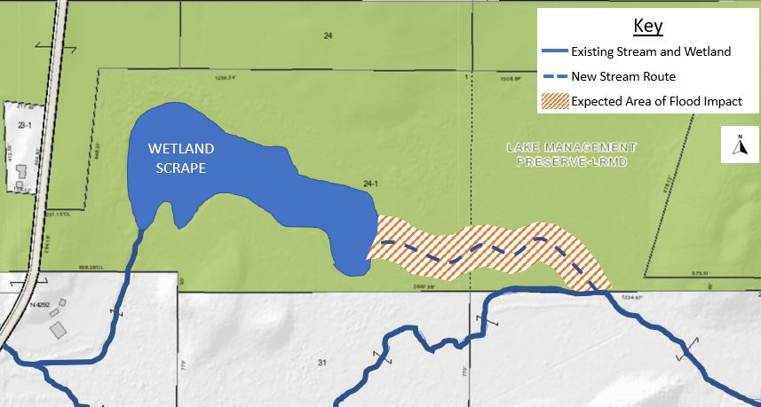
Figure 12: Expected Area of Flow Impact for Alternative 1
The berm and diversion design, Alternative 2, follows behind Alternative 1 in flow impact criteria with the second smallest area. Alternative 2 also completely diverts flow from the existing stream, but in this alternative, there is a risk of flood to the south of the stream diversion on neighboring property. This is due to the use of streambank grading on the north bank of the stream to encourage flooding into the preserve, but there is a risk of flow spilling onto the south streambank with the lack of an excavated channel outlet that exists in Alternative 1. Alternative 2 also will show a greater area of impact in the preserve because flow will dissipate in a scattered style, again, unlike the excavated channel in Alternative 1. Figure 13 shows the anticipated area of impact for Alternative 2 of 400,000 sq. ft.
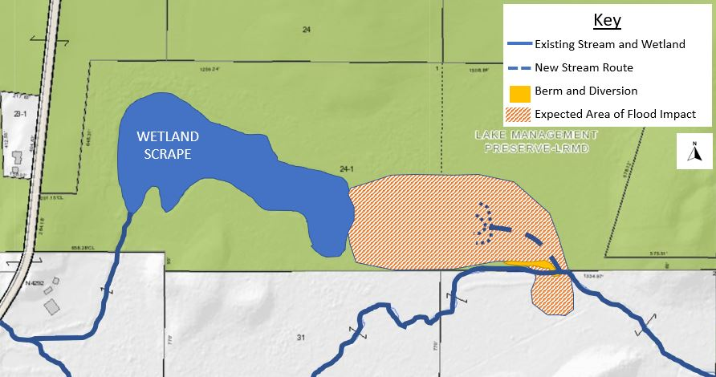
Figure 13: Expected Area of Flow Impact for Alternative 2
Alternative 3, weir installation, has this largest area of impact of the three alternatives. The weir will be installed much farther downstream than the other two alternatives intervention style. Alternative 3’s weir will result in an increased stream stage upstream of its installation, putting much more land at risk of flooding in high rainfall events. The expected area of impact for Alternative 3 is 500,000 sq. ft. and is laid out in Figure 14.
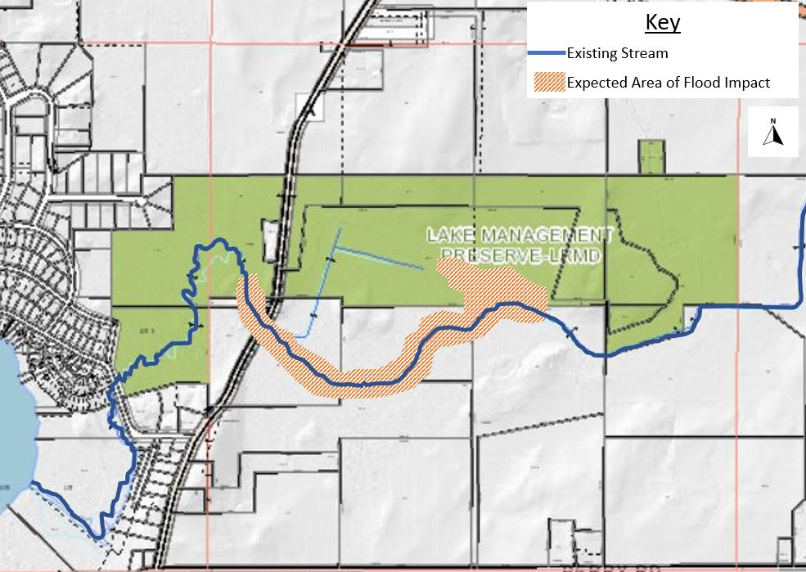
Figure 14: Expected Area of Flow Impact for Alternative 3

6.5 Volume of Water Redirected
For each proposed alternative, maximizing the amount of flow that is redirected is a priority because redirection is indicative of increased exposure to purification processes through the elimination of phosphorus and suspended solids in the stream. Alternatives 1 and 2, the stream channel excavation and berm and diversion alternatives, completely redirect flow from the existing stream. For this reason, both Alternatives 1 and 2 are ranked evenly for a volume of water redirected criteria in the decision matrix. They both divert 0.68 cu. ft. per second or 58,000 cu. ft. per day.
Alternative 3 requires further calculation into the volume of water that is redirected by the design. With a 6” tall weir installed, 36.3% of the cross-sectional area of the stream will be displaced to raise the stage of the stream. This 36.3% at higher elevation is subject to overflowing at the streambank grading that will take place upstream of the weir. 36.3% of the existing flow is 21,000 cu. ft. per day which is the volume of water that will be expected to be redirected by the proposed weir in Alternative 3.

Construction Time Frame
Although much of the construction activities for the three alternatives outlined in this report are dictated by the means and methods of the selected contractor, BPS has determined the construction timeline for Alternatives 1, 2, and 3 to be the longest for Alternative 1, the second longest for Alternative 2, and the fastest to be Alternative 3. Construction for Alternative 3 will likely be dictated by a long lead time for the specified, prefabricated weir, but the earthwork scope is less than that of the other options. A small redirection channel will need to be dug around the weir’s installation point, and the streambank owned by the LRMD will receive grading to encourage flooding, but the total amounts of soil moved remains much less than that of the other options. The BPS team has estimated a construction time frame of 36 weeks for this option.
Alternative 2 Requires more soil to be moved than Alternative 3 due to the excavation of a new, shallower channel into the preserve. This option will also require slightly more intricate excavation to create the proper dispersion of the channel into separate infiltration fingers. However, the soil excavated will be able to be kept on site for the creation of the berm shown in Figure 15. Since the channel is shorter than Alternative 1, less restoration efforts, a labor-intensive activity, will be required for this option. The BPS team has estimated a construction time frame of 42 weeks for this option.
Alternative 1 is expected to have the longest construction timeline because the amount of soil moved is the greatest, the soil must be transported off site, and the streambank restoration scope is significantly larger than the other options. The BPS team has estimated a construction timeline of 45 weeks for this option.

Permitting Required
For each design alternative, permitting remains relatively consistent among each option. Jefferson County and Wisconsin building permits are accompanied by various Wisconsin DNR permits for wetland construction, streambank erosion, water use permits, among others. The difference is in weir construction for Alternative 3, requiring special permits for dam construction. Visit the DNR’s website for water permits related to this project.

6.8 Heavy Equipment Needs
For each alternative there is a certain need for heavy construction equipment. This term refers to large-scale construction equipment such as an excavator, dump truck, bulldozer, etc. While it would be possible to perform each alternative with hand tools and labor, pickaxe, shovel, etc., that is not a reasonable requirement as construction would most likely occur in the winter in order to protect the soil structure in the preserve as much as possible. Of course, there would still need to be staff on site in the winter to operate the machinery, but they would not have to breach the frozen soil themselves. This criterion chosen because the LRMD communicated that they want to limit heavy equipment as much as possible in order to avoid disrupting the existing ecosystem unnecessarily. Alternative 1 is predicted to require one excavator in order to dig the shallow channel for the inlet stream to divert into, and a dump truck in order to carry any excess soil off of the site. Similarly, alternative 2 would require an excavator to dig the initial diversion from the existing stream bed, but for a much shorter distance than with alternative 1. Additionally, a bulldozer would be needed in order to use the soil that had been excavated in order to create the berm. Lastly, alternative 3 would need the most intense construction equipment. On top of an excavator and dump truck, similar to alternatives 1 & 2, to grade the northern stream bank and remove the excess soils, alternative 3 requires an excavator and a crane in order to install the weir farther downstream. Thus, alternative 3 is the most construction-intensive option.

6.9 Social Justice
For the initial design phase of this project, Lianna Spencer from the LRMD directed BPS to assume that neighboring property owners would be supportive of any change to stream flow on their property. This helped BPS to flesh out what viable alternatives could be, but one of the considerations of which alternative should be recommended is how many neighbors would be impacted by the plan – the social justice aspect. Alternatives 1 and 2 both impact the stream flow by cutting off or greatly reducing the flow downstream of the construction site, thus they only affect three out of the seven neighboring properties. See Figure 15 for a visual depiction of the properties that will be affected.
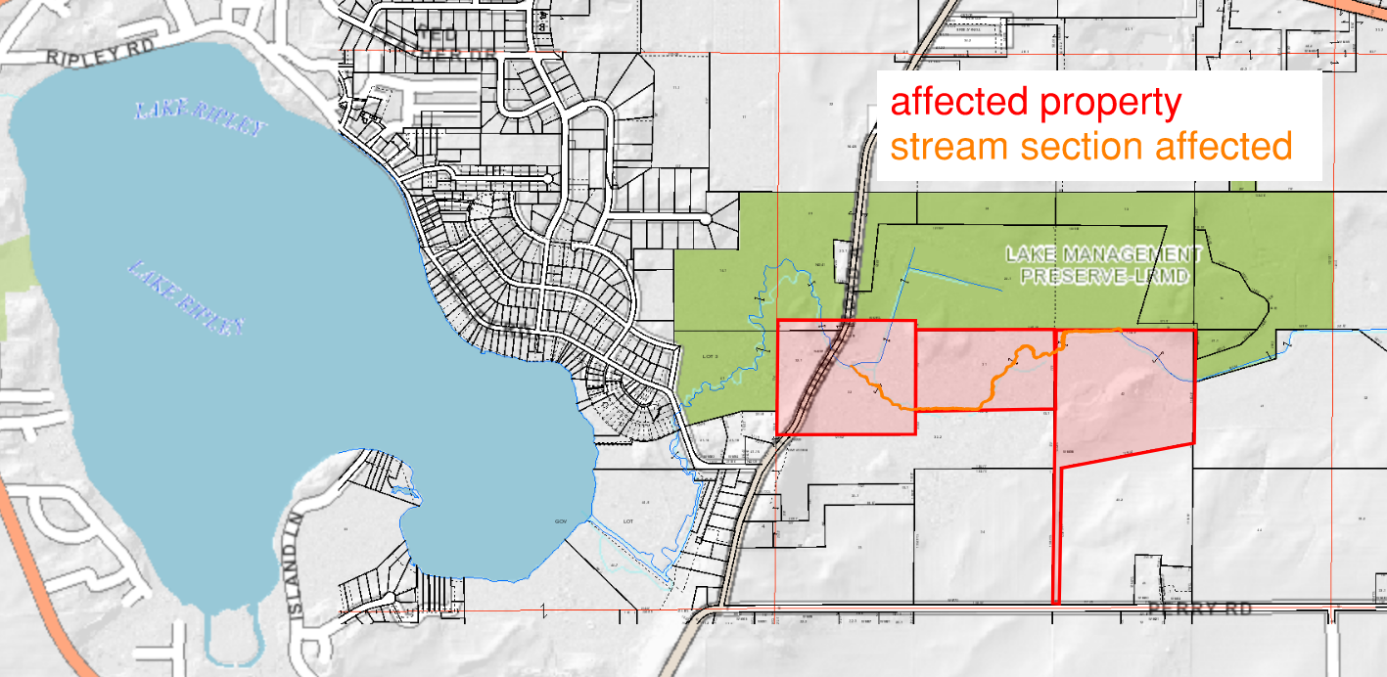
Figure 15: Depiction of properties that will be impacted with alternatives 1 and 2
On the other hand, alternative 3 will affect all seven properties that are near to the preserve with the stream running through them. In Figure 16 six of the seven properties affected by the stream level rising due to the weir can be seen. The seventh property is just to the west of the figure frame, the stream continues on that way.
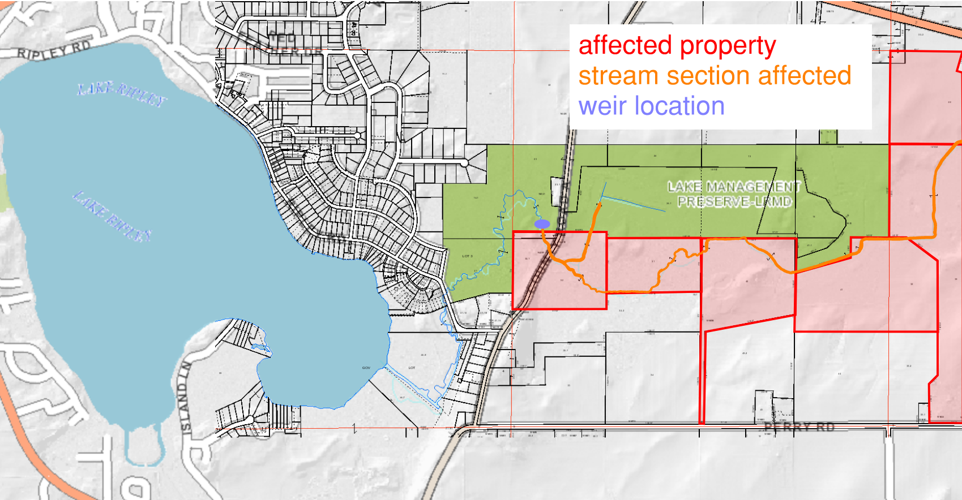
Figure 16: Depiction of properties that will be impacted with alternative 3
These figures show that the impact on neighboring properties is much larger for alternative 3 than for alternatives 1 or 2.

6.10 Long Term Maintenance
One of the goals of this project was for BPS to make this new stream flow as simple to upkeep as possible for LRMD. As a taxpayer funded special governmental body, the LRMD has to be selective about which projects they are able to tackle in a given time frame. An option that needs constant maintenance would not be a productive option for the client. Alternative 2 requires no long-term maintenance. Once the new channel is dug, the stream flow will follow that new path. While some flow may still continue down the existing channel, that volume will be greatly reduced, allowing the majority of the water to flood into the preserve. The excavated path will continue to be solidified by the stream flow eroding it. The second alternative requires relatively little maintenance, it should be inspected every five years to make sure that the stream flow has not eroded away the berm too much. Erosion of the berm in itself is no issue, but if the berm is close to collapsing that could lead to the inlet stream no longer reaching the LRMD preserve. Thus, once every five years the berm should be inspected for structural stability. Lastly, alternative 3 requires the most maintenance by far. After the weir is inserted, it will need to at least be inspected, maintenance would be applied as needed, every six months. Weir inspection twice a year would be a large commitment for LRMD as the inspection would have to happen in various seasons and may need an outside contractor to assist. Thus, alternative 1 requires the least amount of long-term maintenance.

7.0 Opinion of Probable Costs
BPS has developed a preliminary cost opinion for the proposed water quality improvements in the Lake Ripley Watershed. Due to uncertainties such as material costs at the time of acquisition and ambiguity of existing site conditions, this estimate is subject to uncertainty and will shift as more information is gathered during the final design phase. A cost estimate will be provided with the final design report that narrows down the costs with more detail.
Each alternative was itemized for construction to estimate a total cost. A 20% contingency was used to accommodate for any uncertainties at this stage in design and will be find-tuned in the final design phase. Alternative 1, channel excavation, has an estimated total of $244,000. The berm and diversion alternative, Alternative 2, comes in at a project estimate of $282,000. Alternative 3, the weir installation alternative, has an estimated project cost of $328,000. Table 2, Table 3, and Table 4 lay out the itemized cost estimates for Alternatives 1, 2, and 3, respectively.
All alternatives have estimated project costs that come well within the project budget of $2 million. The estimates provided are consistent with industry standard projects of this scope, and the three proposed alternatives each accomplish the primary and secondary goals set by LRMD of stripping contaminants such as phosphorus, nitrogen, and suspended solids from surface water entering Lake Ripley and flooding areas of the Lake District Preserve that have been invaded by Reed Canary Grass.
The largest differences between estimated costs of the proposed alternatives involves the extra equipment and materials needed to install a weir in Option 3. Because this alternative requires equipment access both at the site of the weir and upstream for streambank grading, two excavators are necessary as well as the added cost of the weir itself and its transport and installation.
In comparing Alternative 1’s cost estimate to that of Alternative 2, Alternative 2 requires more extensive coverage with the seed mix that will reintroduce native plant species on the preserve where excavation and destruction occurs. The increased cost of seed mix for Alternative 2 pushes its cost estimate above the cost to construct Alternative 1. Other itemized costs between these alternatives remain similar.
Table 22: Proposed Cost Estimate for Alternative 1
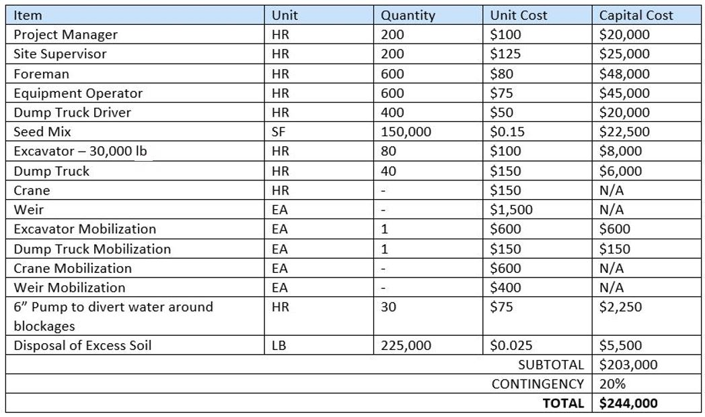
Table 33: Proposed Cost Estimate for Alternative 2
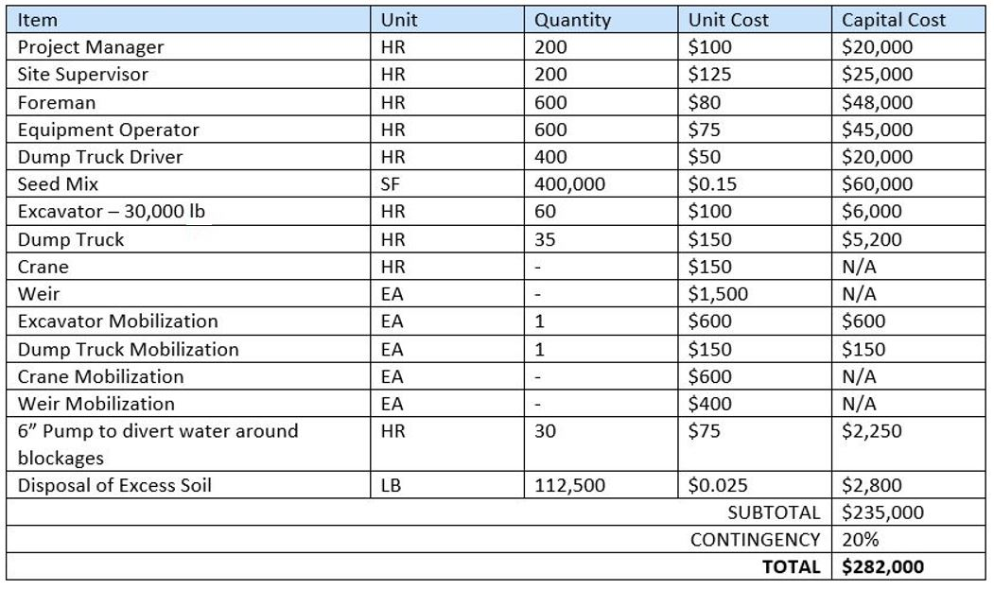
Table 44: Proposed Cost Estimate for Alternative 3
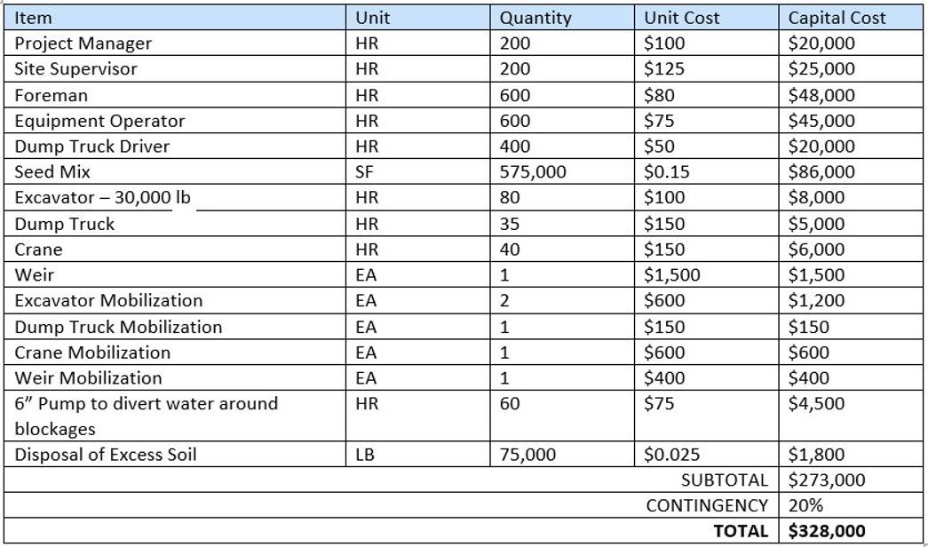

8.0 Project Schedule

9.0 Social Sustainability

9.1 Economic
All three alternatives were designed with economic sustainability in mind as the LRMD is a governmental body that is funded by taxpayers. It is critical that the taxpayer money is spent well to generate results for the community. After construction, alternatives 1 and 2 have very little long-term maintenance requirements, making them solutions that could provide for LRMD for years to come at a low cost for the time frame of use. On the other hand, alternative 3 needs to be inspected every six months to make sure that the weir is still structurally sound and functioning as it should be. While this is more costly in the long term, it is still a relatively low cost for the lifetime of the weir because the manufacturer anticipates no repairs being needed.
Beyond the long-term considerations of economic sustainability, each of these three alternatives are extremely cost effective. With the most expensive option being under $350,000, all of the alternatives that are proposed are well below budget – making the project affordable for LRMD to make the changes they desire to the ecosystem.

9.2 Environmental
Environmental concerns were the driving force in the creation of this project. The goal of creating an avenue for the influent stream to be stripped of phosphorus, nitrogen, and suspended sediment would be achieved with any of the three alternatives that are proposed in this report. In order to preserve the existing ecosystem of the LRMD preserve that surrounds the stream, BPS selected construction and excavation during the winter in order to minimize the impact of the heavy machinery on the soil structure and microbiome. Additionally, each of the alternatives would be viable options for years to come. With minimal maintenance the alternatives can be upkept which means that there is no need for heavy construction equipment in the future. The lake environment will be improved while the wetland environment in the preserve will be protected. The LRMD provided various seed mix options that they have used in the past, see Appendix 4-7. These seed mixes will be used in proportion as directed by the LRMD in order to stabilize the freshly graded soil and begin the process of habitat reconstruction.

9.3 Safety
BPS is committed to the highest standard of safety. Each BPS jobsite is OSHA compliant, and every BPS employee and contractor is empowered to stop work if they feel that a practice is unsafe. Daytime construction hours will also increase jobsite safety with daylight, warmer temperatures, and less fatigue. Additionally, since the construction will be occurring in a Wisconsin winter, the project manager on site will be informed about the early warning signs of frostbite and hypothermia and how to act accordingly for the workers’ safety. Construction sites should employ the “5 S Principles” of lean construction to keep a safe and clean construction site. Fortunately the job site is not on a public roadway, so the construction should not be a traffic hazard in any way. Lastly, since construction is occurring on an active waterway, DNR protocol will be followed throughout the excavation process in order to prevent pollutants and topsoil from entering the influent stream and eventually Lake Ripley.

9.4 Social
BPS and the LRMD are committed to maintain a socially sustainable project throughout the project’s lifecycle by fostering community opinion of the project. As mentioned previously in the report, BPS will collaborate with the Town of Cambridge and the LRMD to have a public forum where community members can voice their opinions and concerns. Once into the construction phase, daylight construction will limit disruption to residents during the night, which is crucial given the construction site’s proximity to neighboring properties. Secondly, maximum decibel levels will be enforced at the edge of the jobsite so that the neighbors and general community are not disturbed. Lastly, the construction traffic will be closely monitored on the path to the jobsite and through the access road in order to avoid disrupting the community and the preserve ecosystem.
Prior to breaking ground the project purpose, scope, and sustainability plans will be made public so that social sustainability is strong from the beginning. Throughout the process as a whole BPS will maintain transparency in order to continuously prove the commitment to sustainability by openly sharing project goals and receiving ongoing community concerns.

10.0 Uncertainties
There are a number of sources for uncertainty in the existing site evaluation and preliminary design of water quality improvements for the Lake Ripley watershed.

10.1 Data-Based Uncertainty
Data-based uncertainty largely is a result of given or known information that is lacking in detail or precision to gain a complete understanding. Elevation data is one source of data-based uncertainty in this project. The Jefferson County website provides 2-foot contour topographic maps that give a good image of what the project site looks like, but there is uncertainty in the exact profile of the stream. It is not a large enough waterway to have extensive profile data. Elevations are estimated based on data collected from the Jefferson County website and site visits to investigate the stream profile. This data-based uncertainty also presented challenges in attempting to model streamflow. Because there was not enough detail to know slight changes in elevation, the modeling software used, HEC-RAS, could not pick up on contours of the surrounding areas and struggled to develop a functioning model.

10.2 Knowledge-Based Uncertainty
Knowledge-based uncertainty includes the lack of information and assumptions that need to be made for each site. Soil conditions for this project needed to be interpolated due to a lack of existing borings on the project site. USDA NRCS Soil Survey data was used to determine a general scope of subsurface conditions. Soil borings from other areas that matched the NRCS data were used to make an estimation of bearing capacity and settlement. To resolve this uncertainty in the future, BPS would recommend taking new borings for any construction that will be occurring at the project site.

10.3 Uncertainty in Estimate of Probable Cost
Assumptions made in the estimation of probable cost are reliant upon stable market prices. Material prices may fluctuate until the beginning of the construction phase resulting in a change to the cost estimate. Material and labor availability are also subject to change before the beginning of construction and may affect the project cost and schedule. Site conditions and subsurface conditions are uncertain due to the knowledge-based soil boring uncertainty discussed previously.

11.0 Recommendations and Conclusion
After careful consideration of our ten decision matrix criteria, focusing on the analysis of environmental, geological, hydrological, and surveying and geotechnical engineering, BPS was able to come to the conclusion to recommend Alternative 1 – Channel Excavation. Initially this result was surprising as alternative 1 requires the most excavation in the wetland. However, it quickly became clear upon further investigation that alternative 1 allows for the most certainty that the water will be treated along with the least amount of long-term maintenance for the client. Especially with the construction stipulation that the excavation should occur while the ground is frozen in order to preserve the soil structure and ecosystem as much as possible, alternative 1 will lead to the most success for the LRMD’s initiative to remove the phosphorus, nitrogen, and suspended solid from the waterway.
BPS is thankful for the opportunity to work on a project that is unique and able to impact the lives of many citizens and the surrounding ecosystem with a client that is supportive of the process. Throughout the design phase LRMD has been informative and a wonderful resource for the team. While alternatives 2 and 3 are also feasible for accomplishing the task that LRMD has set out, alternative 1 has the best balance between all of the decision criteria that was outlined earlier in the report. If LRMD follows the details of any of the alternatives as outlined in this report, they will find great success. BPS recommends alternative 1 but each of the alternatives are fully supported by the BPS team.

Appendix

Calculations
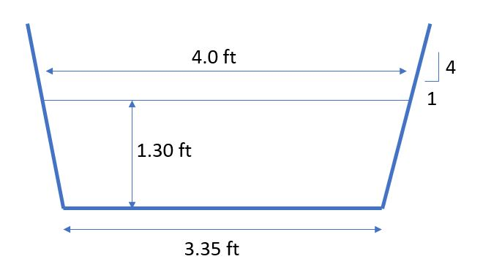
Manning’s Open Channel Flow:
$$Q=\frac{1.49}{n}*A*R^{\frac{2}{3}}*S^{1/2}$$
n = Manning’s Roughness Coefficient (assume n = 0.05 for a channel with scattered brush and weeds)
1.34 ft
S = (842ft – 836ft)/9000ft = 0.00067
$$A=\frac{1}{2}*\left(4ft+3.35ft\right)*1.30ft=4.78 {ft}^{2}$$
$$P_{w}=\left(1.34ft\right)*2+3.35 ft=6.0 ft$$
$$R=\frac{A}{P_{w}}=\frac{4.78{ft}^{2}}{6.0ft}=0.793 ft$$
$$Q=\frac{1.49}{0.05}*\left(4.78{ft}^{2}\right)*{\left(0.793ft\right)}^{\frac{2}{3}}*{\left(0.00067\right)}^{\frac{1}{2}}=0.68 {ft}^{3}/s$$
Displacement of Flow by Proposed Weir:
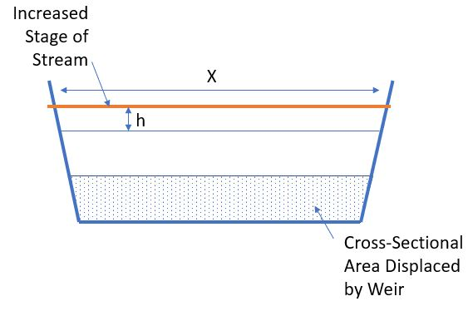
$Area Displaced by Weir=0.5*\left(3.35 ft+3.6 ft\right)*0.5ft=1.7375 sq. ft.$ = 36.3% total cross-sectional area
$$x=4+\left(\frac{h}{4}\right)*2=4+\frac{h}{2}$$
$$1.7375 sq. ft. =0.5*\left(x+4\right)*h=0.5*\left(4+\frac{h}{2}+4\right)*h=>$$
$$h=0.423 ft=5.1 in$$

Figures

Appendix 1: Historic Phosphorus levels in the influent stream as compared with the DNR quality level of allowable phosphorus (0.075 mg/L)

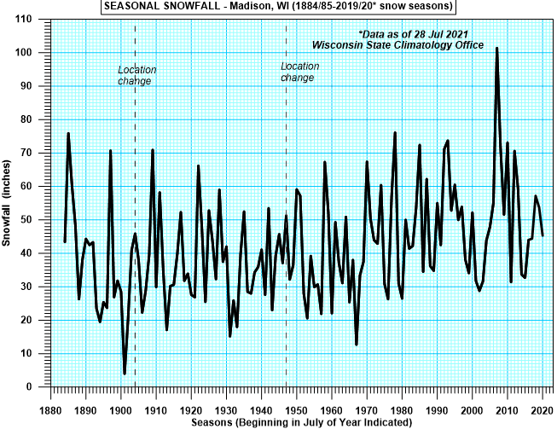
Appendix 2: Historical Seasonal Snowfall in the Greater Madison Area
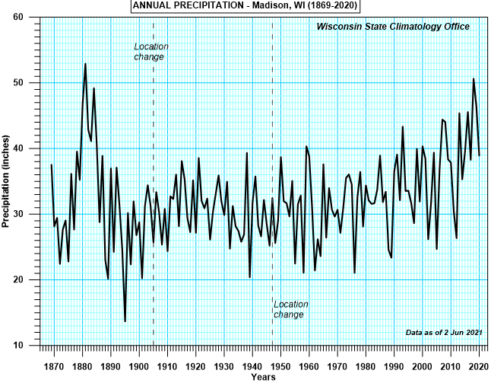
Appendix 3: Historical Annual Precipitation in the Greater Madison Area

Tables
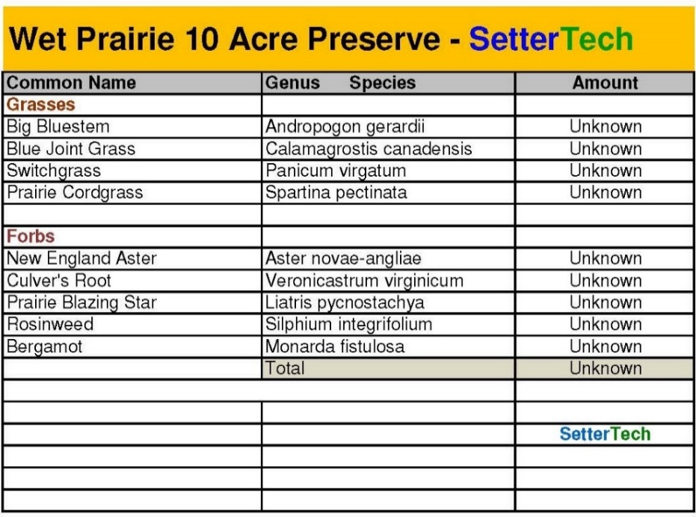
Appendix 4: Wet Prairie 10 Acre Preserve Seed Mix – from LRMD
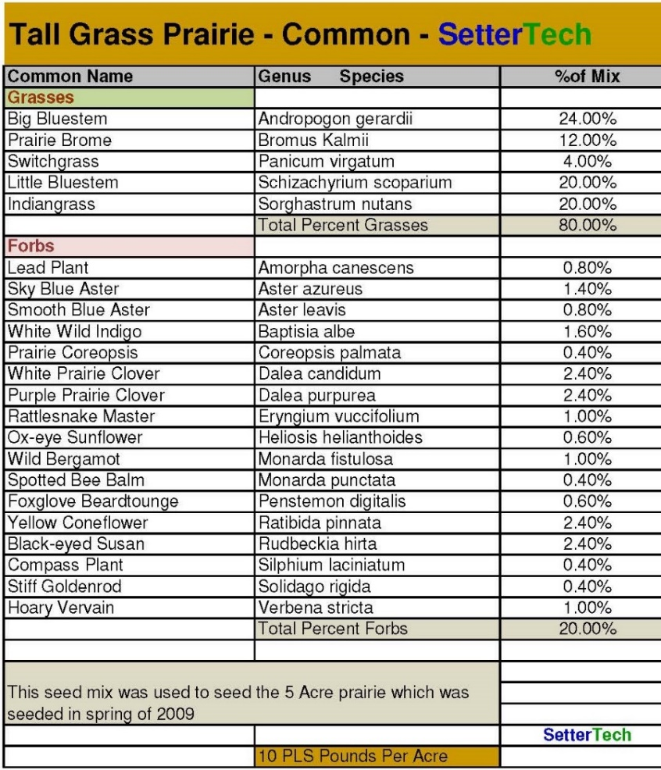
Appendix 5: Tall Grass Prairie Seed Mix – from LRMD
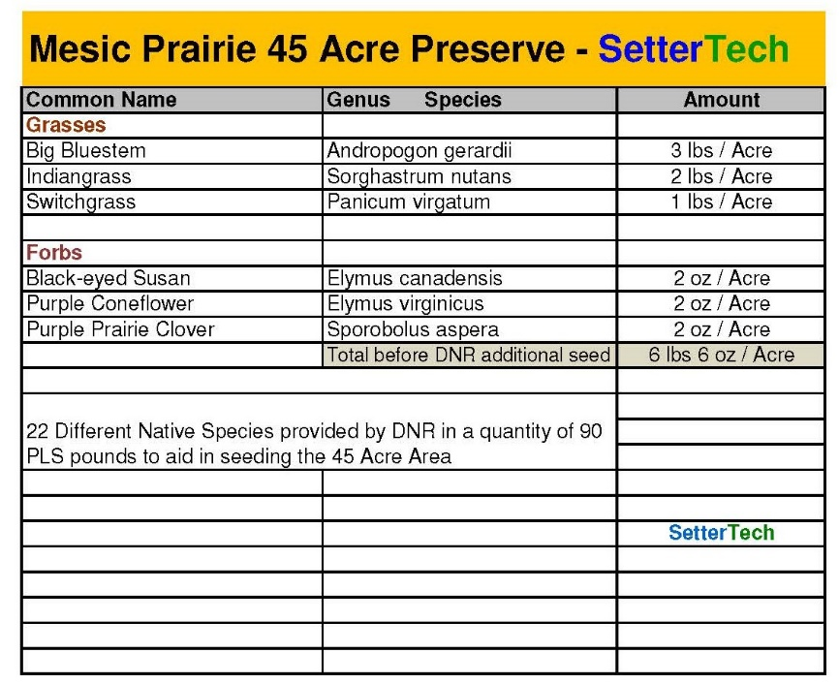
Appendix 6: Mesic Prairie 45 Acre Preserve Seed Mix – from LRMD
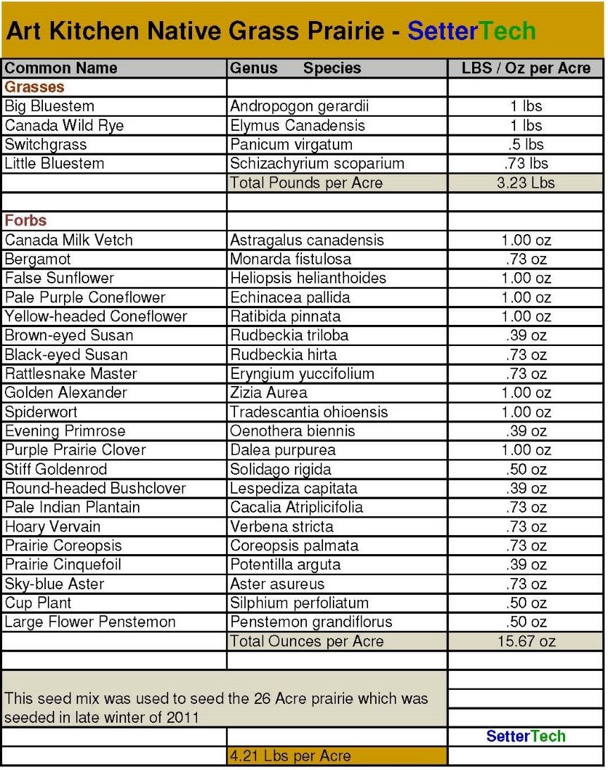
Appendix 7: Art Kitchen Native Grass Prairie Seed Mix – from LRMD
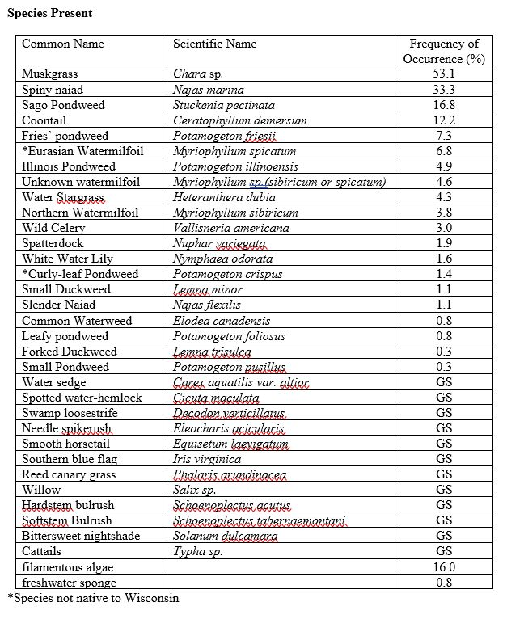
Appendix 8: 2006 LRMD point intercept survey showing relative frequencies of aquatic plants in Lake Ripley
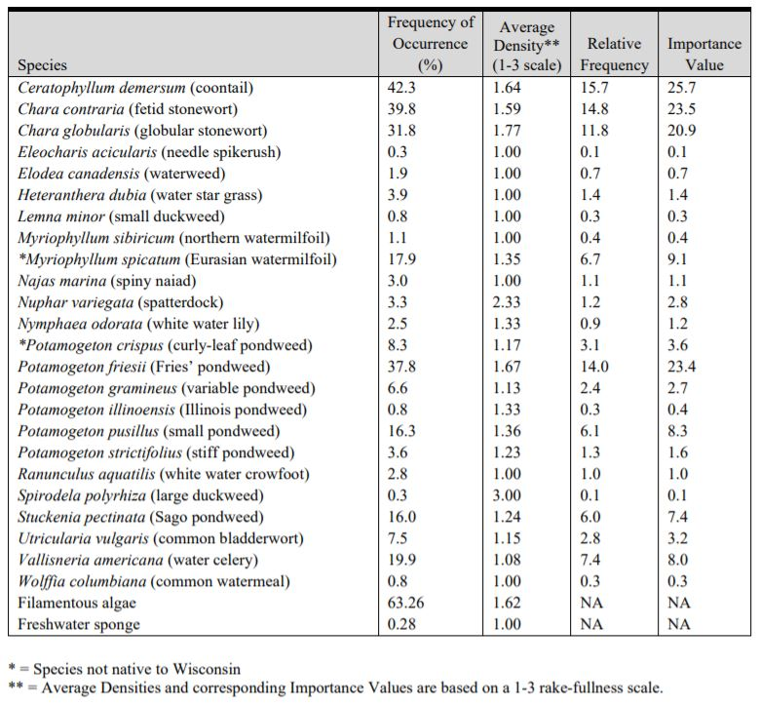
Appendix 9: 2020 LRMD point intercept survey showing relative frequencies of aquatic plants in Lake Ripley

