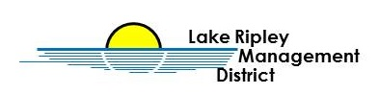

Public Input Session
Tuesday, October 19th, 2021 4:00-5:30pm
Oakland Town Hall
N4450 County Road A
Cambridge, WI, 53523
Agenda

- Welcome and Introductions – Sign-in sheet

- Lake Management Plan Update – Lake Manager

- Public Input Session

- Adjournment

- Meeting input will be recorded via both written record and audiotape.

