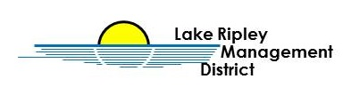
Lake Ripley Management District
Audit Committee
Committee Meeting
August 11th, 2021 at 2:30pm
Oakland Town Hall
N4450 County Road A, Cambridge, WI, 53523
Agenda

- Call to Order and Roll Call

- Public Comment

- New Business

- Review of the 2020/2021 Financial Statements

- Old Business

Adjournment

Note: Public Comment will be taken at discretion of District Chair

Original posted at Hering’s Lake Ripley Inn, Lake Ripley Café, Oakland Town Hall on August 9th, 2021.

