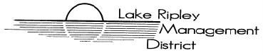
Lake Ripley Management District
Human Resources Committee
Committee Meeting
July 9th, 2020, 7:30AM
Nora’s Two Restaurant
1843 US-12
Deerfield, Wisconsin, 53531
Agenda

- Call to Order and Roll Call

- Public Comment

- Approve Minutes from October 5th, 2020 meeting

- New Business

- Lake Manager evaluation process discussion and possible action

- Old Business

Adjournment

Note: Public Comment will be taken at discretion of District Chair

Original posted at Hering’s Lake Ripley Inn, Lake Ripley Café, Oakland Town Hall on July 6, 2021.

