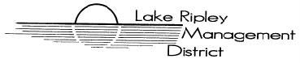
Lake Ripley Management District
Land Acquisition Committee
Committee Meeting
May 19th, 2021 at 2:30pm
Oakland Town Hall
N4450 County Road A, Cambridge, WI, 53523
Agenda

- Call to Order and Roll Call

- Public Comment

- Approve Minutes of February 25th, 2021

- New Business

- Old Business

- Discussion and possible action on land purchase for the benefit of the LRMD
[Meeting may enter Closed Session [as per §Wis. Statute 19.85 (1)(e) to consider land purchase]

Return to Open Session

Adjournment

Note: Public Comment will be taken at discretion of District Chair

Original posted at Hering’s Lake Ripley Inn, Lake Ripley Café, Oakland Town Hall on May 17th 2021.

